Weekly Reporting SNS PPU
WBS P.02.03 Cryomodule Integration (JLab Scope)
March 3, 2023

Issues: None
Accomplishments this week:

Management:
- PPU activities are continuing with cryomodule assembly and receipt inspection of components.
- Off-site work efforts continue in the procurement area on end cans.

Engineering & Design:
- Sustaining engineering activities are continuing in order to revise drawing packages based on feedback during the procurement phase.
- Plan for transmitting complete set of CM drawings – Doc Control Group is preparing drawing package. Shared folder at ORNL is identified. STEP file CAD models have been transferred.

Procurement:
- On March 7, two JLab employees will visit the end can vendor to witness another leak test.

- Supply End Cans (SECs):
S/N | Status | Estimated Delivery Date
01 | Installed on CM-03 | -
02 | Installed on CM-04 | -
03 | Installed on CM-01 | -
04 | Welded onto CM-05 | -
05 | Welded onto CM-06 | -
06 | Delivered to JLab on 6/6. Uncrated, inspections started. Phase 1 dimensional inspection done. Bridge tube angle is off by ~5 degrees. JLAB will try installation of SEC 06 and exercise loosening the hardware at both ends of the elbow/bellows and see how well it corrects. Plan to use on PPU-07. | -
07 | Installed on CM-02 | -
08 | All parts and sub-assemblies done. Album 1 pictures uploaded to share folder. Pulled components and is getting started setting up the final assembly. Working on welded assembly. | Apr 14

- Return End Cans (RECs):
S/N | Status | Estimated Delivery Date
01 | Installed on CM-03
02 | Installed on CM-01
03 | Installed on CM-05
04 | Installed on CM-02
05 | Started welding of fit up bridging tube section. First two welds on bridging is complete. Final testing expected to happen next week. | Mar 14 (JLab estimate)
06 | Installed on CM-04.
07 | Is progressing well with the vacuum shell being welded up by a welder. Working on the external structural this week. Then weld small components to the top plate. | Mar 31 (JLab estimate)
08 | Top plate weldment complete. Finished the Relief Stack weldment. Spools are coming together, MTM is rebuilding a part that was machined incorrectly (Part of the return bayonet), and moving the sub-assemblies through cold-shock/leak test as they are able. Worked on sub-assembly in process leak testing and cleaning. | Apr 28

Production:
- Cryomodule Status:
- CM05: In CTMF and cold at 2K; Ins vac ~2e-7; turbo amp being logged. Initial testing has begun. Expect to warm up late next week.
- CM06: Awaiting REC delivery in mid-March.
- CM07: Cold mass raise to disengage wheel; alignment repeated, better.
- CM08: Ion pump replacement complete.
Project Management:
- Held Progress Meeting
- Held Progress Analysis Meeting
- Provided Monthly Director’s Review Data
- Sent Monthly Schedule Data to ORNL
Quality Assurance:
- Continue to monitor quality data for possible trends.
- Continuing to gather data deliverables for CM05.

Project Photos:
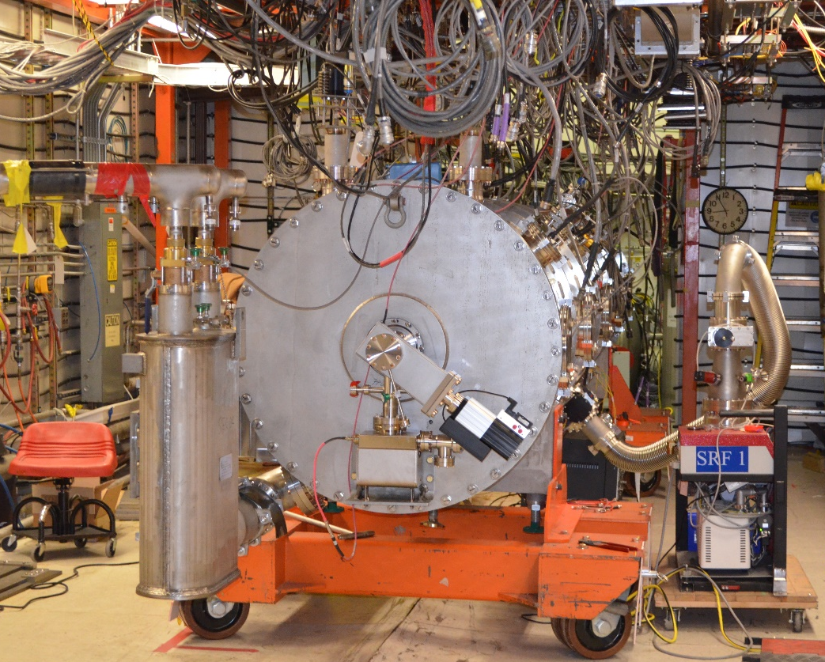
CM05

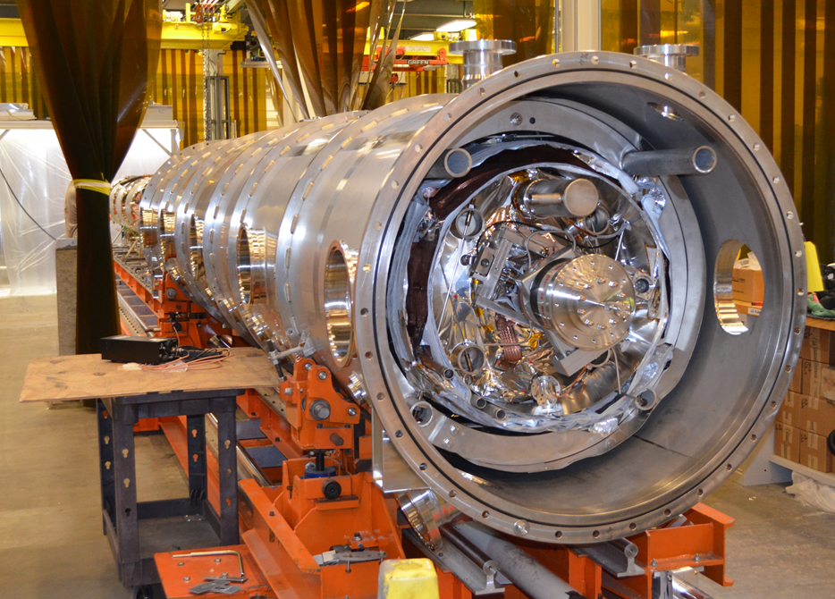
CM07

