Weekly Reporting SNS PPU

WBS P.02.03 Cryomodule Integration (JLab Scope)

March 17, 2023

**Issues:** None

**Accomplishments this week:**

Management:

* PPU activities are continuing with cryomodule assembly and receipt inspection of components.
* Off-site work efforts continue in the procurement area on end cans.
* On track for shipment of PPU-05 to ORNL on 29-March.

Engineering & Design:

* Sustaining engineering activities are continuing in order to revise drawing packages based on feedback during the procurement phase.
* Plan for transmitting complete set of CM drawings – Doc Control Group is preparing drawing package. Shared folder at ORNL is identified.

Procurement:

* One JLab visitor visited the end can vendor on March 7 to witness progress.
* Supply End Cans (SECs):

|  |  |  |
| --- | --- | --- |
| S/N | Status | Estimated Delivery Date |
| 01 | Installed on CM-03 | - |
| 02 | Installed on CM-04 | - |
| 03 | Installed on CM-01 | - |
| 04 | Welded onto CM-05 | - |
| 05 | Welded onto CM-06 | - |
| 06 | Delivered to JLab on 6/6. Uncrated, inspections started. Phase 1 dimensional inspection done. Bridge tube angle is off by ~5 degrees. JLAB will try installation of SEC 06 and exercise loosening the hardware at both ends of the elbow/bellows and see how well it corrects. Plan to use on PPU-07. | - |
| 07 | Installed on CM-02 | - |
| 08 | All parts and sub-assemblies done. Album 1 pictures uploaded to share folder. Pulled components and is getting started setting up the final assembly. Working on welded assembly. In progress, the welder working on this one is currently working part-time due to returning to school. No major progress updates. | Apr 14 |

* Return End Cans (RECs):

|  |  |  |
| --- | --- | --- |
| S/N | Status | Estimated Delivery Date |
| 01 | Installed on CM-03 |  |
| 02 | Installed on CM-01 |  |
| 03 | Installed on CM-05 |  |
| 04 | Installed on CM-02 |  |
| 05 | Final testing started. Cold shock of the primary return circuit done. AI visit scheduled to be on 3/17. Top plate assembly to start next Monday. | Mar 24 (JLab estimate) |
| 06 | Installed on CM-04. |  |
| 07 | Working on the bridging tube segment. | Apr 12 (JLab estimate) |
| 08 | Not much progress: components/spools/etc. being prepped, inventory being gathered. MTM currently searching for CD Valve inner bellows assembly. It may become necessary for us to hunt down a replacement if it cannot be located. | Apr 28 |

Production:

* Cryomodule Status:
* CM05: Shipping planned for March 29; limit switches adjusted.
* CM06: Awaiting REC delivery in late March; planning to go to CMTF at end of May.
* CM07: Cold mass aligned VV; moving forward with assy.
* CM08: Ion pump replacement complete; HV Mu shields on order; difference in REC beampipes noted.

Project Management:

* Distributed VARs for February Month End Update
* Provided the Team with EV Data
* Updated The CAM Notebook

Quality Assurance:

* Continue to monitor quality data for possible trends.
* Continuing to gather data deliverables for CM05.

Project Photos:

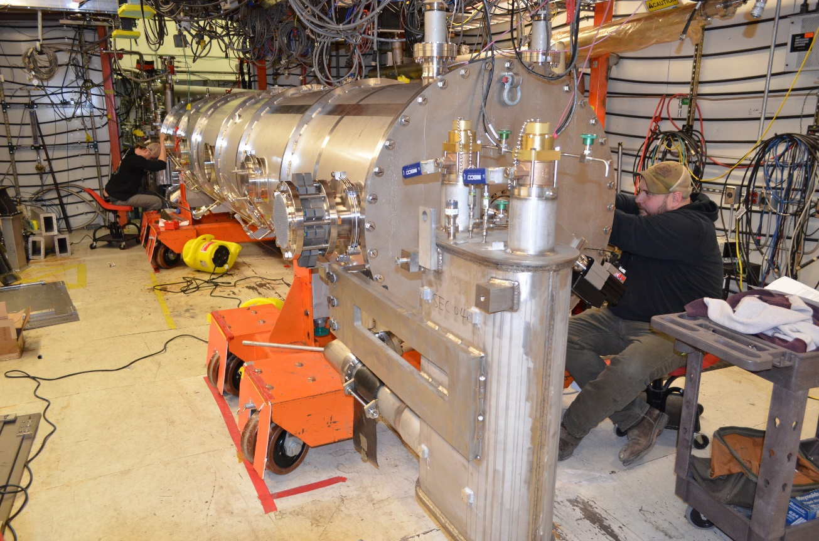

CM05

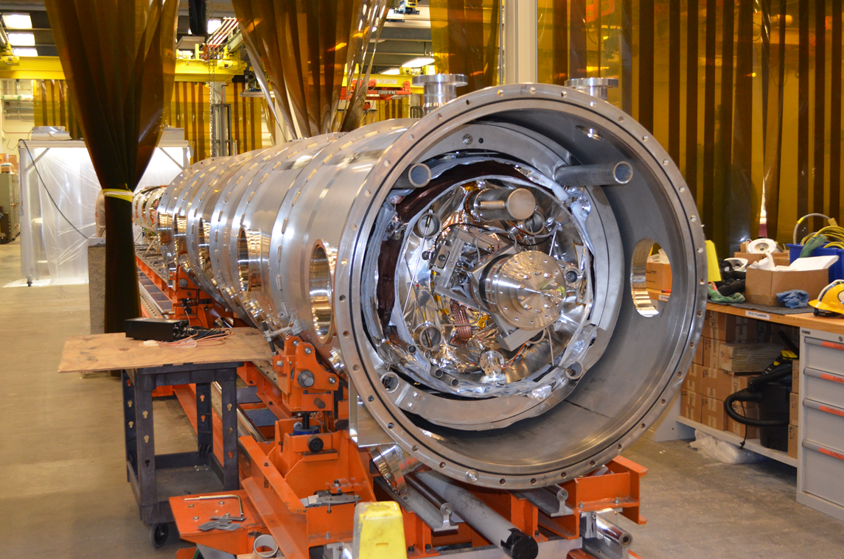

CM07

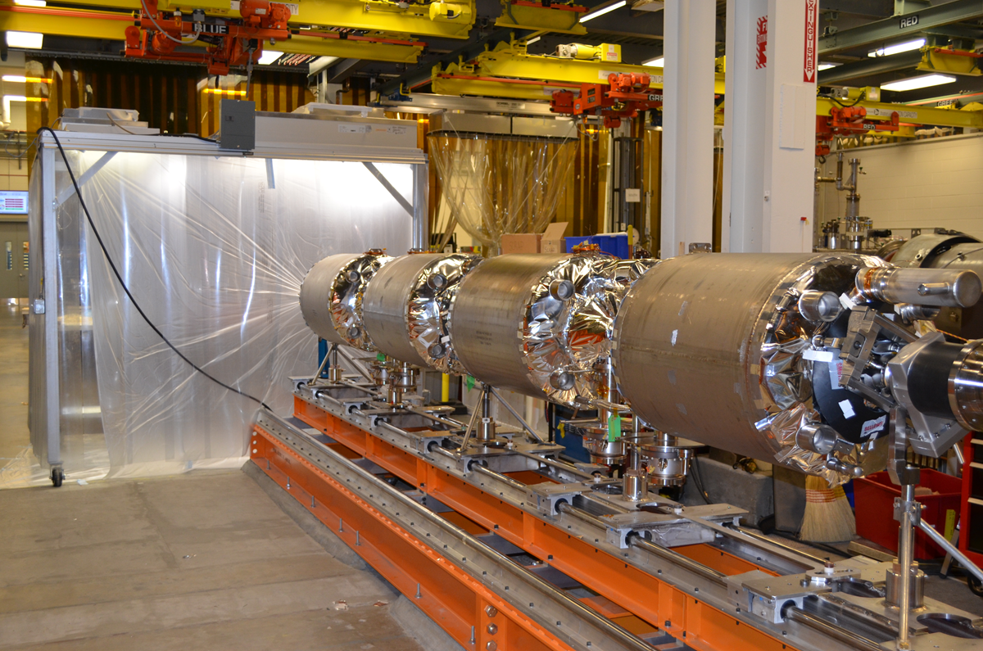

CM08