Weekly Reporting SNS PPU

WBS P.02.03 Cryomodule Integration (JLab Scope)

April 7, 2023

**Issues:** None

**Accomplishments this week:**

Management:

* PPU activities are continuing with cryomodule assembly.
* Off-site work efforts continue in the procurement area on end cans.
* Ashley Mitchell takes over as CAM for the remainder of the project. The project org chart has been updated.

Engineering & Design:

* Sustaining engineering activities are continuing in order to revise drawing packages based on feedback during the procurement phase.
* Plan for transmitting complete set of CM drawings – Doc Control Group is preparing drawing package. Shared folder at ORNL is identified.

Procurement:

* One JLab visitor will visit the end can vendor on April 14 to witness REC 7 final testing.
* Supply End Cans (SECs):

|  |  |  |
| --- | --- | --- |
| S/N | Status | Estimated Delivery Date |
| 01 | Installed on CM-03 | - |
| 02 | Installed on CM-04 | - |
| 03 | Installed on CM-01 | - |
| 04 | Welded onto CM-05 | - |
| 05 | Welded onto CM-06 | - |
| 06 | Delivered to JLab on 6/6. Uncrated, inspections started. Phase 1 dimensional inspection done. Bridge tube angle is off by ~5 degrees. JLAB will try installation of SEC 06 and exercise loosening the hardware at both ends of the elbow/bellows and see how well it corrects. Getting ready to be welded onto PPU-07, see photo. The support block needs machining. | - |
| 07 | Installed on CM-02 | - |
| 08 | At the vendor. Working on spool fit up to the top plate. | May 26 |

* Return End Cans (RECs):

|  |  |  |
| --- | --- | --- |
| S/N | Status | Estimated Delivery Date |
| 01 | Installed on CM-03 |  |
| 02 | Installed on CM-01 |  |
| 03 | Installed on CM-05 which will be shipped to ORNL by end of the month. Vendor will prepare a nonconformity report on the leaks discovered during final testing. |  |
| 04 | Installed on CM-02 |  |
| 05 | Delivered to JLab on 3/31. Visual and weld inspections are performed. Insulating vacuum established. Currently getting ready for pressure leak check, see picture attached. |  |
| 06 | Installed on CM-04. |  |
| 07 | Vendor is working on it. Finished the external miter elbow on bridging section. Added the test caps and now needs to add the lines that come out the test cover. Dimensional inspection to start soon. AI witnessed testing scheduled to happen on 4/14. | Apr 21 |
| 08 | The Control Valve Assembly’s inner rod assembly is welded and in testing. This should wrap up Album 1 work on sub-assemblies. | June 9 |

Production:

* Cryomodule Status:
* CM05: At ORNL awaiting high power testing.
* CM06: Awaiting REC upon completion of inspection.
* CM07: Began installation of SEC.
* CM08: Leak check FPC bellows and ¼” lines on cold mass assembly.

Project Management:

* Help Progress Analysis
* Provided Schedule Package to ORNL
* Updated Manpower Charts for March mid-Month
* Updated The CAM Notebook

Quality Assurance:

* Data deliverables for CM05 were uploaded to the SharePoint site.
* Continue to monitor quality data for possible trends.

Project Photos:

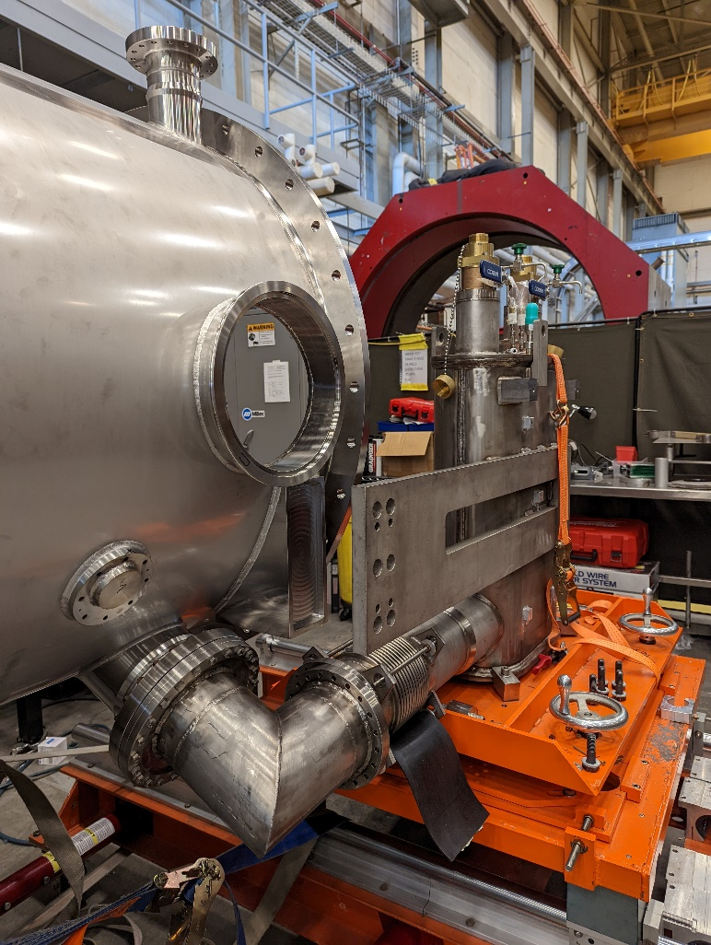

SEC-06 on CM-07

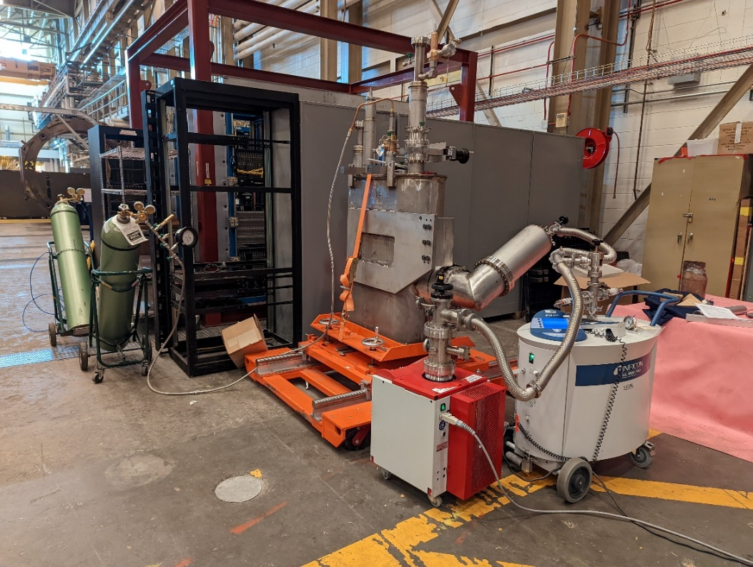

REC-05 pressure leak check