Weekly Reporting SNS PPU
WBS P.02.03 Cryomodule Integration (JLab Scope)
April 14, 2023

Issues: None
Accomplishments this week:

Management:
- PPU activities are continuing with cryomodule assembly.
- Off-site work efforts continue in the procurement area on end cans.

Engineering & Design:
- Sustaining engineering activities are continuing in order to revise drawing packages based on feedback during the procurement phase.
- Plan for transmitting complete set of CM drawings – Doc Control Group has prepared drawing package. Shared folder at ORNL is identified. SNS PPU lead designer is verifying drawing package completeness.

Procurement:
- One JLab visitor visited the end can vendor on April 14 to witness REC 7 final testing. Unit pass all tests and was stamped by the AI.
- Supply End Cans (SECs):
S/N | Status | Estimated Delivery Date
01 | Installed on CM-03 | -
02 | Installed on CM-04 | -
03 | Installed on CM-01 | -
04 | Welded onto CM-05 | -
05 | Welded onto CM-06 | -
06 | Delivered to JLab on 6/6. Uncrated, inspections started. Phase 1 dimensional inspection done. Bridge tube angle is off by ~5 degrees. Welded onto PPU-07. The support block is machined, bridge tube bellows is largely skewed due to dimensional deviations on the SEC 06. See photo. | -
07 | Installed on CM-02 | -
08 | At the vendor. Vendor worked on spools to thermal shield. Will set up for test of spools Friday with JLab visitor. | May 26

- Return End Cans (RECs):
S/N | Status | Estimated Delivery Date
01 | Installed on CM-03
02 | Installed on CM-01
03 | Installed on CM-05
04 | Installed on CM-02
05 | Delivered to JLab on 3/31. Inspection near completion. REC 5 is being aligned to PPU-06. Initial misalignment is quite large. Bridge tube bellows is expected to absorb large displacements if it can still maintain integrity, see photo.
06 | Installed on CM-04
07 | Vendor is working on it. Vacuum boundary test complete. Set up and starting (4/13) cold flow tests. AI and JLab visit on Friday 4/14 resulted in approval as unit pass all tests. | Apr 26 from MTM
08 | Album 1 submitted but missing photos of critical welds. Start set up for welded assembly. | June 9

Production:
- Cryomodule Status:
- CM05: At ORNL awaiting high power testing.
- CM06: REC R.I. complete; install I.P.
- CM07: SEC installed; process piping welding in progress
- CM08: HV Mu shields on order; SF/VV on tooling; align crew fiducializing today. Coupler line welding issues, braze. Couple of attempts; leak tight. Cold shocking in progress.
Project Management:
- Updated March Monthly EV Data
- Provided March Month End Manpower Data
- Distributed VARs for Updates
- Updated the CAM Notebook
Quality Assurance:
- Data deliverables for CM05 were uploaded to the SharePoint site.
- Continue to monitor quality data for possible trends.

Project Photos:
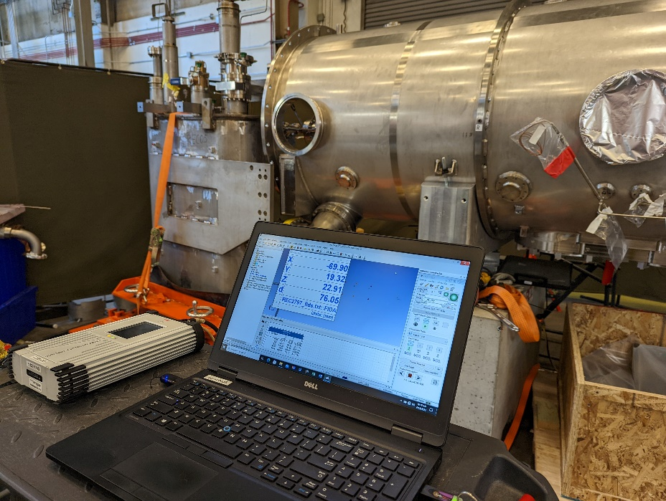
REC-05 to PPU-06
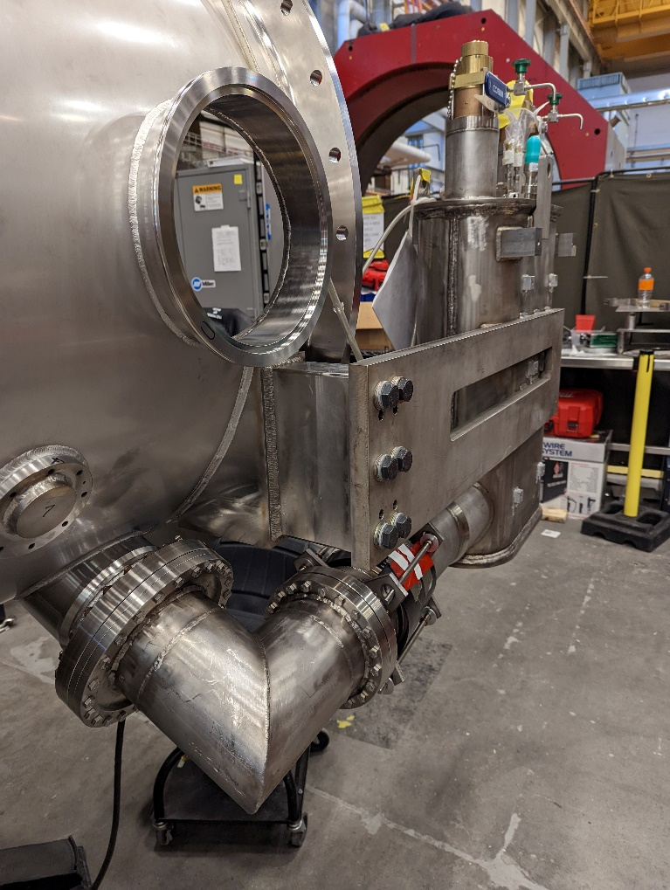
SEC-06 welded to PPU-07
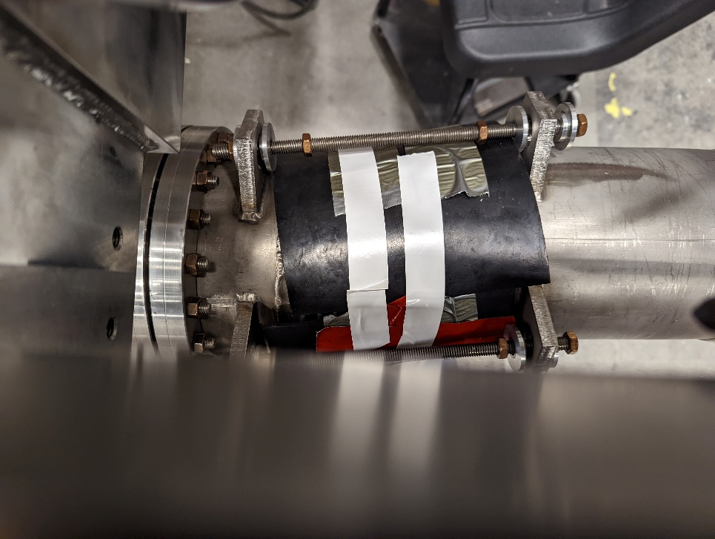
SEC-06 bellows skewed

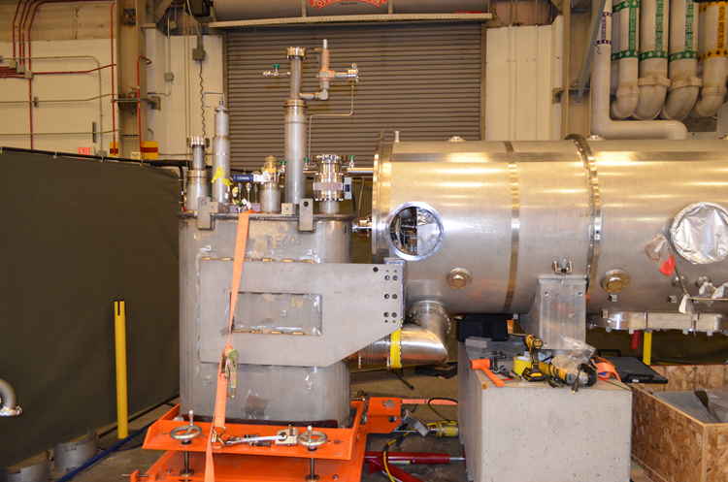
CM-06

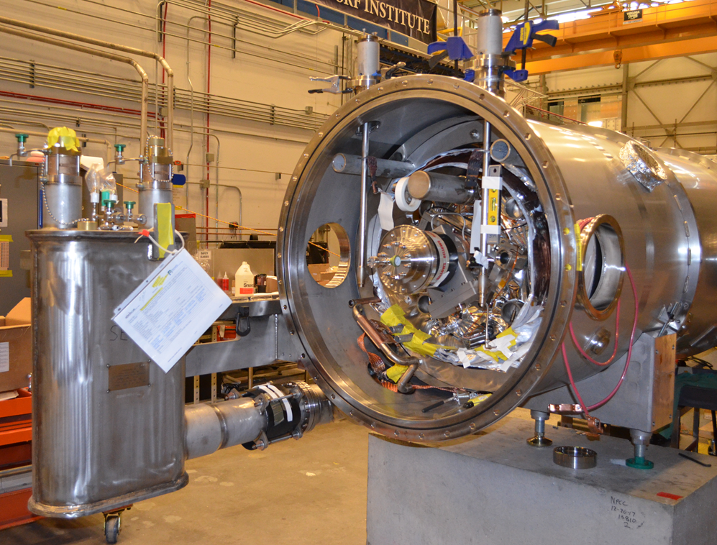
CM-07
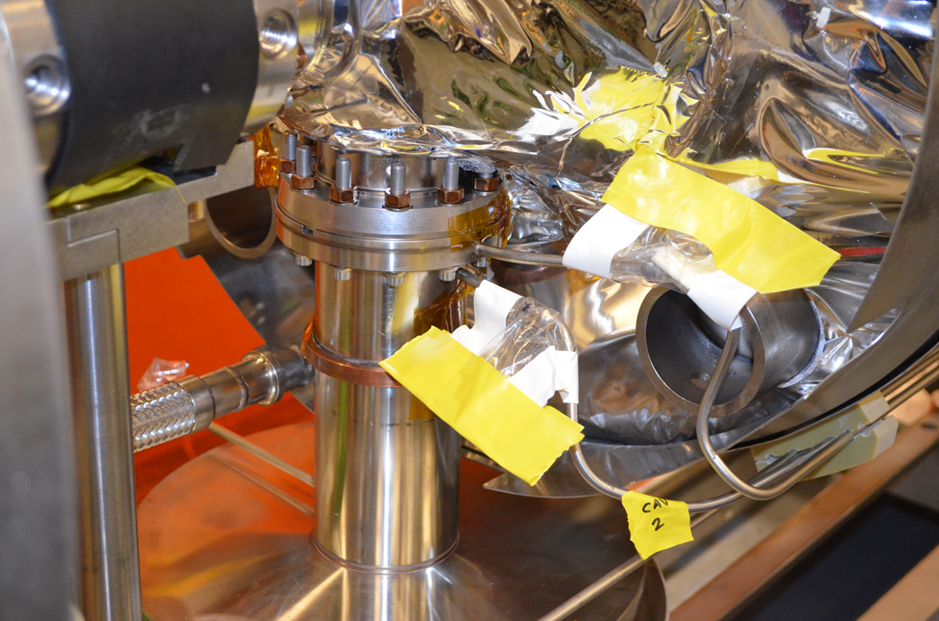
CM-08 Coupler line welding issue being addressed

