Weekly Reporting SNS PPU

WBS P.02.03 Cryomodule Integration (JLab Scope)

April 21, 2023

**Issues:** None

**Accomplishments this week:**

Management:

* PPU activities are continuing with cryomodule assembly.
* Off-site work efforts continue in the procurement area on end cans.

Engineering & Design:

* Sustaining engineering activities are continuing in order to revise drawing packages based on feedback during the procurement phase.
* Plan for transmitting complete set of CM drawings – SNS PPU lead designer is verifying drawing package completeness.

Procurement:

* One JLab visitor visited the end can vendor on April 14 to witness REC 7 final testing.
* Supply End Cans (SECs):

|  |  |  |
| --- | --- | --- |
| S/N | Status | Estimated Delivery Date |
| 01 | Installed on CM-03 | - |
| 02 | Installed on CM-04 | - |
| 03 | Installed on CM-01 | - |
| 04 | Installed on CM-05 | - |
| 05 | Installed onto CM-06 | - |
| 06 | Delivered to JLab on 6/6. Uncrated, inspections started. Phase 1 dimensional inspection done. Bridge tube angle is off by ~5 degrees. Welded onto PPU-07. The support block is machined, bridge tube bellows is largely skewed due to dimensional deviations on the SEC 06. | - |
| 07 | Installed on CM-02 | - |
| 08 | At the vendor. Spools welded to top plate, thermal shield brazed in place, leak check of primary and shield circuits passed. Complete internal MLI. Routed wiring. Assembling thermal shield. Preparing for braze of straps for bridging tube shield tube. Made necessary G11 stand offs. | May 26 |

* Return End Cans (RECs):

|  |  |  |
| --- | --- | --- |
| S/N | Status | Estimated Delivery Date |
| 01 | Installed on CM-03 |  |
| 02 | Installed on CM-01 |  |
| 03 | Installed on CM-05 |  |
| 04 | Installed on CM-02 |  |
| 05 | Delivered to JLab on 3/31. Inspection work complete. REC 5 is in position on CM-06. Bridge tube bellows has large deformation. Support block needs to be made new. |  |
| 06 | Installed on CM-04 |  |
| 07 | ASME boundary pressure test complete, AI signed off. Top plate items will be finalized, i.e. CD Valve installed, Feedthroughs completed, Ball Valve/Gate Valve installed, relief stack completed, etc. | Apr 26 departs from Vendor |
| 08 | Album 1 submitted but missing photos of critical welds, which are not all done yet. Top plate welded assembly in progress. | June 9 |

Production:

* Cryomodule Status:
* CM06: REC install I.P.; new interface block being made; rework SEC valve interference.
* CM07: SEC process piping welding complete; preparing for LC
* CM08 SF test fit I.P.; coupler line repair complete; remaining inner mag shields installed.

Project Management:

* Provided Team with Monthly EV Reports
* Provided Team with Monthly EV Information
* Updated April Mid-Month Manpower Charts
* Updated CAM Notebook

Quality Assurance:

* Continue to monitor quality data for possible trends.
* Beginning to gather/review data deliverables for CM-06.

Project Photos:

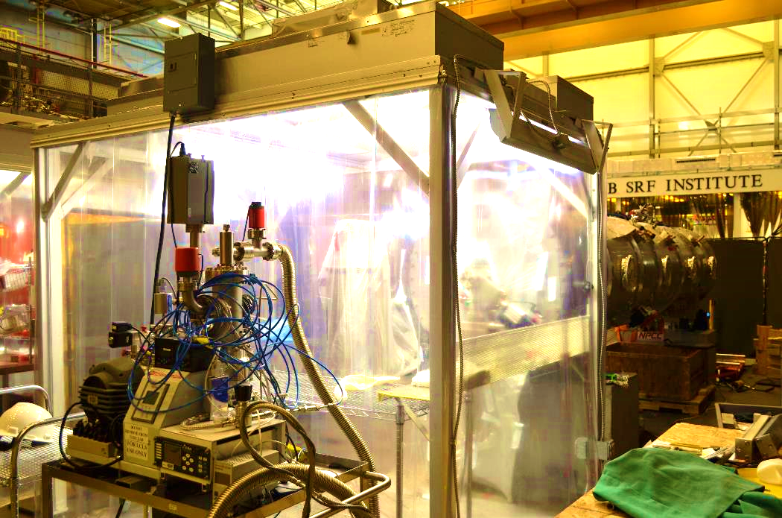

CM-06

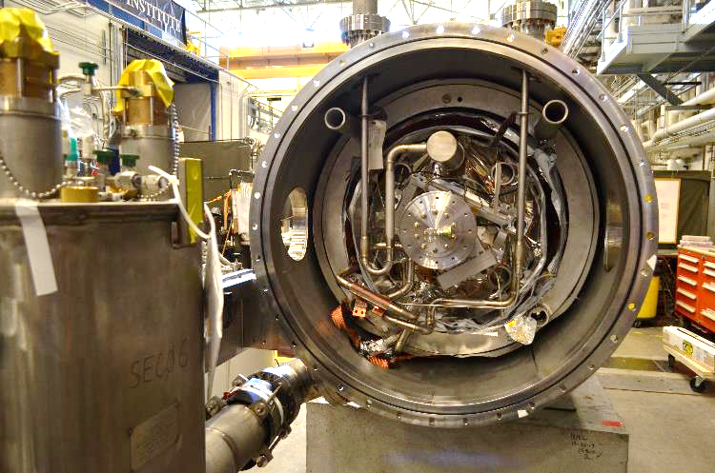

CM-07

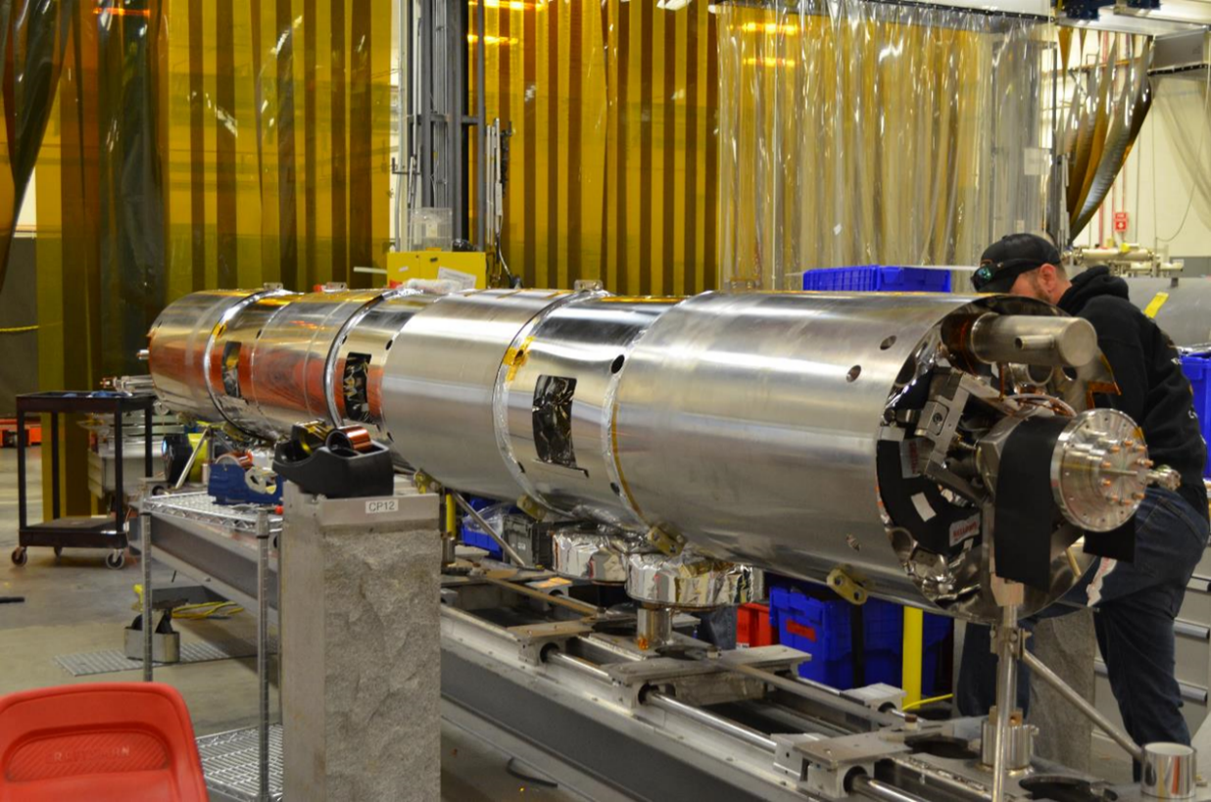

CM-08