Weekly Reporting SNS PPU

WBS P.02.03 Cryomodule Integration (JLab Scope)

May 5, 2023

**Issues:** None

**Accomplishments this week:**

Management:

* PPU activities are continuing with cryomodule assembly.
* Off-site work efforts continue in the procurement area on end cans.

Engineering & Design:

* Sustaining engineering activities are continuing in order to revise drawing packages based on feedback during the procurement phase with a focus on end can drawing packages.
* Plan for transmitting complete set of CM drawings – SNS PPU lead designer is verifying drawing package completeness.

Procurement:

* Two from JAB are visiting the end can vendor to witness REC 8 in process 2k supply & return circuits leak check. Next visit likely in the week of 5/8 to witness more leak check of REC 8 circuits.
* Supply End Cans (SECs):

|  |  |  |
| --- | --- | --- |
| S/N | Status | Estimated Delivery Date |
| 01 | Installed on CM-03 | - |
| 02 | Installed on CM-04 | - |
| 03 | Installed on CM-01 | - |
| 04 | Installed on CM-05 | - |
| 05 | Installed onto CM-06 | - |
| 06 | Delivered to JLab. Uncrated, inspections started. Phase 1 dimensional inspection done. Bridge tube angle is off by ~5 degrees. Welded onto PPU-07. The support block is machined, bridge tube bellows is largely skewed due to dimensional deviations on the SEC 06. | - |
| 07 | Installed on CM-02 | - |
| 08 | At the vendor. Cold mass/shield assembly work complete. Vacuum shell welding ongoing (see picture). | May 26 |

* Return End Cans (RECs):

|  |  |  |
| --- | --- | --- |
| S/N | Status | Estimated Delivery Date |
| 01 | Installed on CM-03 |  |
| 02 | Installed on CM-01 |  |
| 03 | Installed on CM-05 |  |
| 04 | Installed on CM-02 |  |
| 05 | Delivered to JLab on 3/31. Inspection work complete. REC 5 is in position on CM-06. Bridge tube bellows has large deformation. A new support block has been made. |  |
| 06 | Installed on CM-04 |  |
| 07 | On the way to ship to JLab, took a detour to Florida. | May 5 |
| 08 | Album 1 work completed, all sub-assemblies are complete. The high pressure 3/4" supply line and the main run of the low pressure 2" line are welded to the heat exchanger HX036, leak check passed. See picture attached. | June 22 |

Production:

* Cryomodule Status:
* CM-06: REC install I.P.; SEC rework complete.
* CM-07: SEC process piping LC I.P.; REC delivery ~5/8.
* CM-08: SF test fit complete; install over Cold Mass I.P.

Project Management:

* Held Progress Meeting
* Held Progress Analysis Meeting
* Sent Schedule Package to ORNL
* Updated CAM Notebook

Quality Assurance:

* Continue to monitor quality data for possible trends.
* Continuing to gather/review data deliverables for CM-06.

Project Photos:

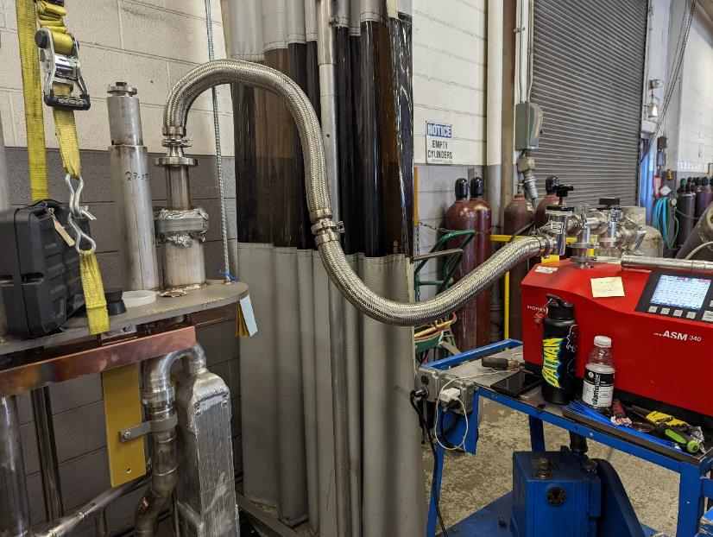

REC-08

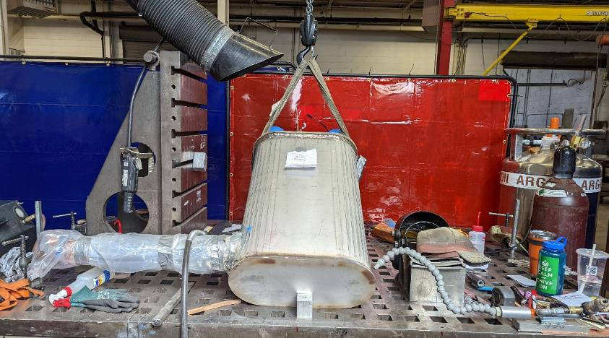

SEC-08

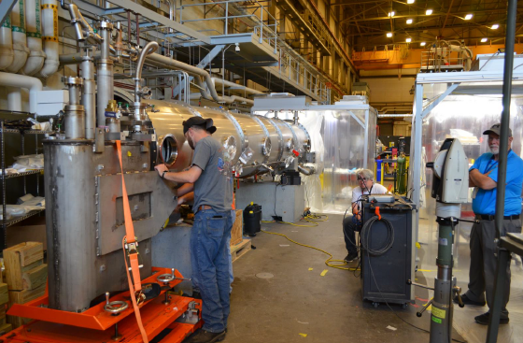

CM-06

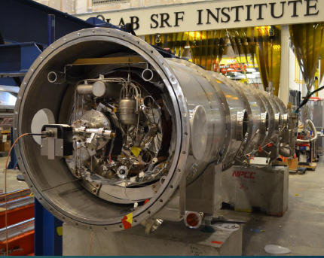

CM-07

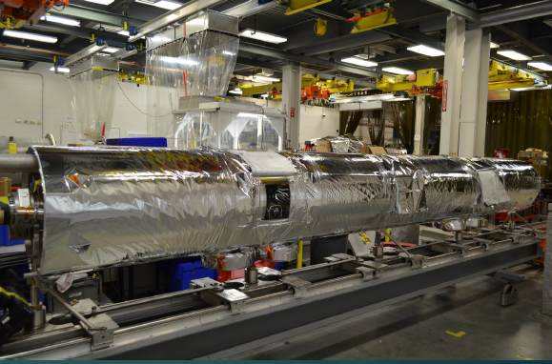

CM-08