Weekly Reporting SNS PPU

WBS P.02.03 Cryomodule Integration (JLab Scope)

May 12, 2023

**Issues:** None

**Accomplishments this week:**

Management:

* PPU activities are continuing with cryomodule assembly.
* Off-site work efforts continue in the procurement area on end cans.

Engineering & Design:

* Sustaining engineering activities are continuing in order to revise drawing packages based on feedback during the procurement phase with a focus on end can drawing packages.

Procurement:

* One visitor from JLab will visit the end can vendor on 5/18 to witness SEC 8 and REC 8 leak checks.
* Supply End Cans (SECs):

|  |  |  |
| --- | --- | --- |
| S/N | Status | Estimated Delivery Date |
| 01 | Installed on CM-03 |  |
| 02 | Installed on CM-04 |  |
| 03 | Installed on CM-01 |  |
| 04 | Installed on CM-05 |  |
| 05 | Installed onto CM-06 |  |
| 06 | Delivered to JLab. Uncrated, inspections started. Phase 1 dimensional inspection done. Bridge tube angle is off by ~5 degrees. Welded onto PPU-07. The support block is machined, bridge tube bellows is largely skewed due to dimensional deviations on the SEC 06. |  |
| 07 | Installed on CM-02 |  |
| 08 | At the vendor. Album 2 cold mass/shield assembly work complete. Temperature sensors are being installed. MLI going on internal piping. Mid of next week, MLI goes onto the thermal shield, that is the final step before installing vacuum shell. | May 26 |

* Return End Cans (RECs):

|  |  |  |
| --- | --- | --- |
| S/N | Status | Estimated Delivery Date |
| 01 | Installed on CM-03 |  |
| 02 | Installed on CM-01 |  |
| 03 | Installed on CM-05 |  |
| 04 | Installed on CM-02 |  |
| 05 | Delivered to JLab on 3/31. Inspection work complete. REC 5 is in position on CM-06. Bridge tube bellows has large deformation. A new support block has been welded onto PPU-06 cryomodule. |  |
| 06 | Installed on CM-04 |  |
| 07 | Delivered to JLab on 5/8. Uncrated on 5/10. Receiving inspection work has started. |  |
| 08 | Vacuum shell welded. External structural welded. Working on long straight section with bellows welding. Intent is to do last internal piping welds in bridging section leak test by mid of next week. | June 22 |

Production:

* Cryomodule Status:
* CM-06: REC welding complete•REC process piping done, leak check I.P.; On target for early June cooldown
* CM-07: SEC process piping LC Complete; REC inspection on-going.
* CM-08: SF installed over Cold Mass; Alignment to start 5/16

Project Management:

* Updated Month End Manpower Reports
* Updated EV Data
* Sent Cost Package to ORNL
* Provided Data Call Information
* Updated CAM Notebook

Quality Assurance:

* Continue to monitor quality data for possible trends.
* Continuing to gather/review data deliverables for CM-06.

Project Photos:

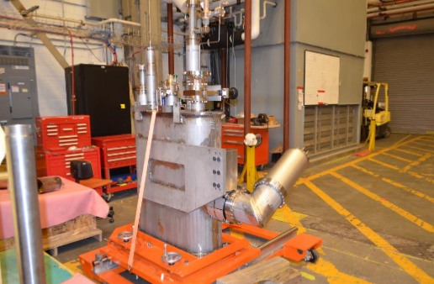

Return End Can for CM-07 received

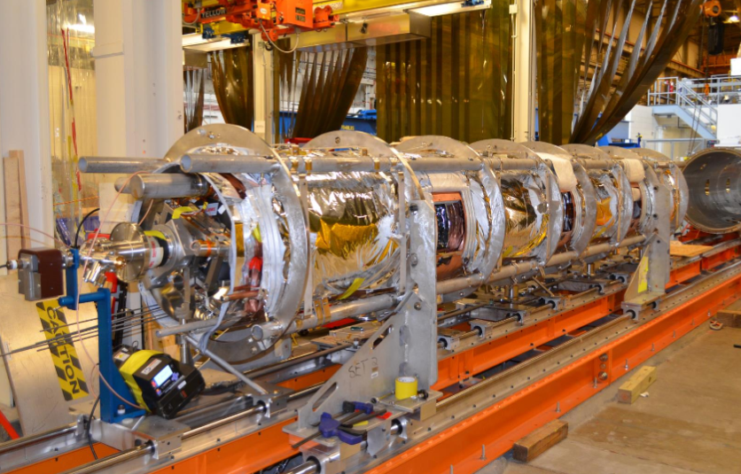

CM-08 Space Frame installed over the cold mass