Weekly Reporting SNS PPU

WBS P.02.03 Cryomodule Integration (JLab Scope)

May 19, 2023

**Issues:** None

**Accomplishments this week:**

Management:

* PPU activities are continuing with cryomodule assembly.
* Off-site work efforts continue in the procurement area on end cans.

Engineering & Design:

* Sustaining engineering activities are continuing in order to revise drawing packages based on feedback during the procurement phase with a focus on end can drawing packages.

Procurement:

* One JLab person visited the end can vendor on 5/18 to witness SEC 8 and REC 8 leak checks.
* Supply End Cans (SECs):

|  |  |  |
| --- | --- | --- |
| S/N | Status | Estimated Delivery Date |
| 01 | Installed on CM-03 |  |
| 02 | Installed on CM-04 |  |
| 03 | Installed on CM-01 |  |
| 04 | Installed on CM-05 |  |
| 05 | Installed onto CM-06 |  |
| 06 | Delivered to JLab. Uncrated, inspections started. Phase 1 dimensional inspection done. Bridge tube angle is off by ~5 degrees. Welded onto PPU-07. The support block is machined, bridge tube bellows is largely skewed due to dimensional deviations on the SEC 06. |  |
| 07 | Installed on CM-02 |  |
| 08 | At the vendor. Album 2 cold mass/shield assembly work complete. Passed leak test of flex lines in bridging tube area. | Jun 5 |

* Return End Cans (RECs):

|  |  |  |
| --- | --- | --- |
| S/N | Status | Estimated Delivery Date |
| 01 | Installed on CM-03 |  |
| 02 | Installed on CM-01 |  |
| 03 | Installed on CM-05 |  |
| 04 | Installed on CM-02 |  |
| 05 | Delivered to JLab on 3/31. Inspection work complete. REC 5 is in position on CM-06. Bridge tube bellows has large deformation. A new support block has been welded onto PPU-06 cryomodule. |  |
| 06 | Installed on CM-04 |  |
| 07 | Delivered to JLab on 5/8. Uncrated on 5/10. Receiving inspection work has started and still ongoing. Pressure tests to happen soon. |  |
| 08 | Vendor is doing visual inspection of Cold Mass prior to vacuum vessel assembly. Completed MLI and will be moving on to having the vacuum shell installed. | June 22 |

Production:

* Cryomodule Status:
* CM-06: REC process piping leak check complete; REC end closing I.P.; on target for early June cooldown.
* CM-07: REC receipt inspection LC/PT’s done; alignment 5/23.
* CM-08: CS Alignment complete; adding 50K and MLI Patch panels.

Project Management:

* Updated Mid-Month Manpower Reports
* Completed VARs
* Updated CAM Notebook

Quality Assurance:

* Continue to monitor quality data for possible trends.
* Continuing to gather/review data deliverables for CM-06.

Project Photos:

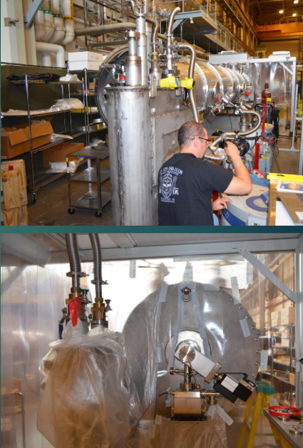

CM-06

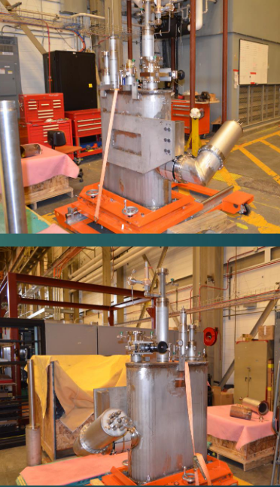

CM-07

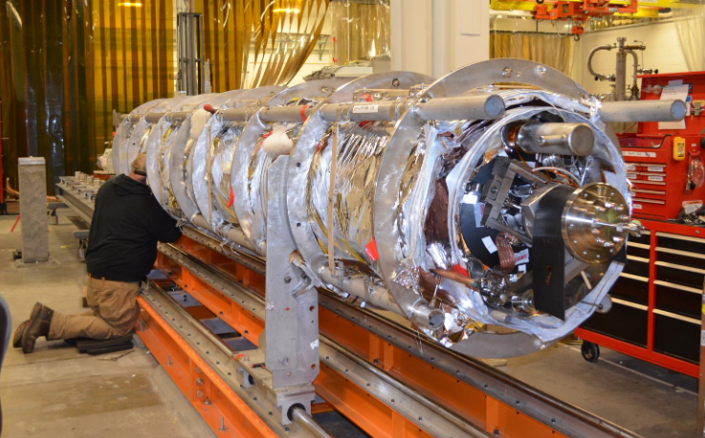

CM-08