Weekly Reporting SNS PPU

WBS P.02.03 Cryomodule Integration (JLab Scope)

May 26, 2023

**Issues:** None

**Accomplishments this week:**

Management:

* PPU activities are continuing with cryomodule assembly.
* Off-site work efforts continue in the procurement area on end cans.
* Presented PPU status at internal Monthly Director’s Review.

Engineering & Design:

* Sustaining engineering activities are continuing in order to revise drawing packages based on feedback during the procurement phase with a focus on end can drawing packages.

Procurement:

* Supply End Cans (SECs):

|  |  |  |
| --- | --- | --- |
| S/N | Status | Estimated Delivery Date |
| 01 | Installed on CM-03 |  |
| 02 | Installed on CM-04 |  |
| 03 | Installed on CM-01 |  |
| 04 | Installed on CM-05 |  |
| 05 | Installed onto CM-06 |  |
| 06 | Delivered to JLab. Uncrated, inspections started. Phase 1 dimensional inspection done. Bridge tube angle is off by ~5 degrees. Welded onto PPU-07. The support block is machined, bridge tube bellows is largely skewed due to dimensional deviations on the SEC 06. |  |
| 07 | Installed on CM-02 |  |
| 08 | At the vendor. Album 2 cold mass/shield assembly work complete. Elbow/Flex Line welds complete. Currently working on bridging tube angled portion. | Jun 5 |

* Return End Cans (RECs):

|  |  |  |
| --- | --- | --- |
| S/N | Status | Estimated Delivery Date |
| 01 | Installed on CM-03 |  |
| 02 | Installed on CM-01 |  |
| 03 | Installed on CM-05 |  |
| 04 | Installed on CM-02 |  |
| 05 | Delivered to JLab on 3/31. Inspection work complete. REC 5 is in position on CM-06. Bridge tube bellows has large deformation. A new support block has been welded onto PPU-06 cryomodule. |  |
| 06 | Installed on CM-04 |  |
| 07 | Delivered to JLab on 5/8. Uncrated on 5/10. Receiving inspection work has started and still ongoing. To mate with PPU-07 and complete dimensional inspection later this week. |  |
| 08 | All interior structure is complete and wrapped in MLI. Album 2 (subassemblies) work completed. Vendor is working on the vacuum shell. | June 22 |

Production:

* Cryomodule Status:
* CM-06: REC end closing done; beam line work complete; final alignment done; on target for early June cooldown.
* CM-07: SEC process piping LC complete; end can R.I. in progress; align crew May 26.
* CM-08: CS alignment complete; adding 50k and MLI patch panels.

Project Management:

* Sent Accrual Information ORNL
* Completed VARs
* Distributed Progress Sheets
* Updated CAM Notebook

Quality Assurance:

* Continue to monitor quality data for possible trends.
* Continuing to gather/review data deliverables for CM-06.

Project Photos:

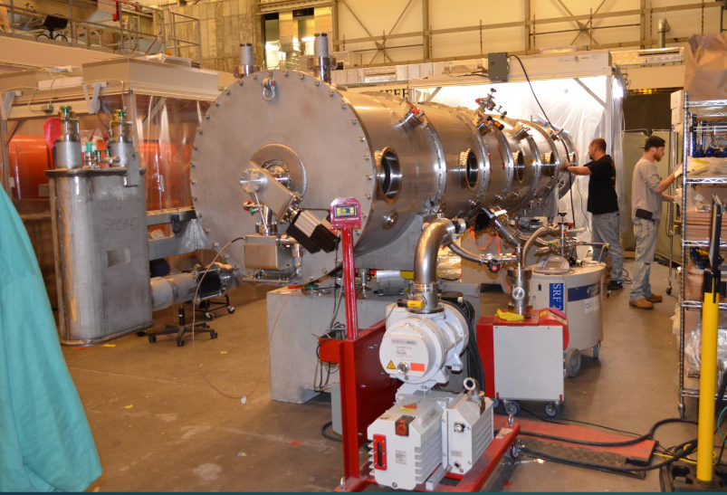

CM-06

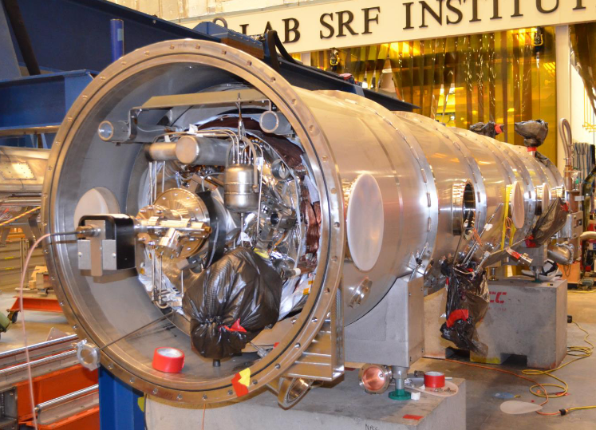

CM-07

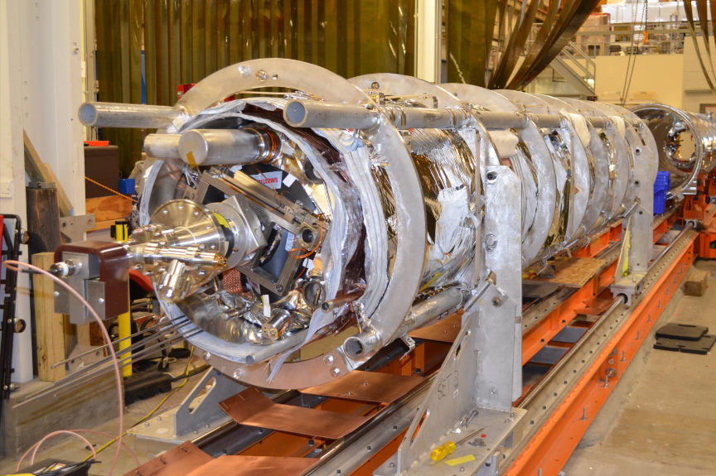

CM-08