Weekly Reporting SNS PPU

WBS P.02.03 Cryomodule Integration (JLab Scope)

June 9, 2023

**Issues:** CM-06 cooldown was delayed until 6/13 due to cooldown valve repair that was completed. The shipping date has been moved by one week, new date is 6/29.

**Accomplishments this week:**

Management:

* New requirements for after-hours work are emerging at JLab.  We are working to ensure that CM-06 cooldown is minimally impacted due to this potential change in operation. The after hours work request has been approved.
* PPU activities are continuing with cryomodule assembly.
* Off-site work efforts continue in the procurement area on end cans.

Engineering & Design:

* Sustaining engineering activities are continuing in order to revise drawing packages based on feedback during the procurement phase with a focus on end can drawing packages.

Procurement:

* End Can vendor visit TBC for end of next week.
* Supply End Cans (SECs):

|  |  |  |
| --- | --- | --- |
| S/N | Status | Estimated Delivery Date |
| 01 | Installed on CM-03 |  |
| 02 | Installed on CM-04 |  |
| 03 | Installed on CM-01 |  |
| 04 | Installed on CM-05 |  |
| 05 | Installed onto CM-06 |  |
| 06 | Delivered to JLab. Uncrated, inspections started. Phase 1 dimensional inspection done. Bridge tube angle is off by ~5 degrees. Welded onto PPU-07. The support block is machined, bridge tube bellows is largely skewed due to dimensional deviations on the SEC 06. |  |
| 07 | Installed on CM-02 |  |
| 08 | At the vendor. Album 2 cold mass/shield assembly work complete. Elbow/Flex Line welds complete. Currently working to complete flanged section of the bridging tube. Plan to be prepping for final testing next week. Currently in process of trying to set up date next week for ASME test | Jun 22 |

* Return End Cans (RECs):

|  |  |  |
| --- | --- | --- |
| S/N | Status | Estimated Delivery Date |
| 01 | Installed on CM-03 |  |
| 02 | Installed on CM-01 |  |
| 03 | Installed on CM-05 |  |
| 04 | Installed on CM-02 |  |
| 05 | Delivered to JLab on 3/31. Inspection work complete. REC 5 is in position on CM-06. Bridge tube bellows has large deformation. A new support block has been welded onto PPU-06 cryomodule. Found that the JT valve seat is missing. There is what appears to be weld residual above the JT valve bottom adapter, where a seat is threaded to. |  |
| 06 | Installed on CM-04 |  |
| 07 | Delivered to JLab on 5/8. Uncrated on 5/10. Receiving inspection work has started and still ongoing. REC 7 is welded to PPU-07 cryomodule after a repair on the bridge tube section. |  |
| 08 | All interior structure is complete and wrapped in MLI. Album 2 (subassemblies) work completed. Vendor is working on bridging tube. Leak check of bridging tube inner lines is planned to happen next week. | Jul 13 |

Production:

* Cryomodule Status:
* CM-06: Installed in CMTF; Cooldown valve seat was repaired and installed. Pressure tests were completed. After hours work requests approved.
* CM-07: REC piping welding on-going.
* CM-08: Idle. Nearly ready for SF/TS installation into VV.

Project Management:

* Sent Schedule Package to ORNL
* Started EV Reports
* Updated CAM Notebook

Quality Assurance:

* Continue to monitor quality data for possible trends.
* Continuing to gather/review data deliverables for CM-06.
  + SNSPPU-AFR-002 created for CM-06
    - To Do:
      * Ensure all relevant Work Control Documents related to the product are closed.
      * Confirm data deliverables are complete.
      * Customer confirmation – ready to receive.
      * Property Transfer Form Prepared.
      * SRF Shipping Form prepared.
      * Bill of Lading Form prepared.
      * Traveler ID: SNSPPU-CMA-CM-ASSY for CM-06 is still in progress
* Open NCRs:
  + 1 on REC 005 on CM-06 needs attention

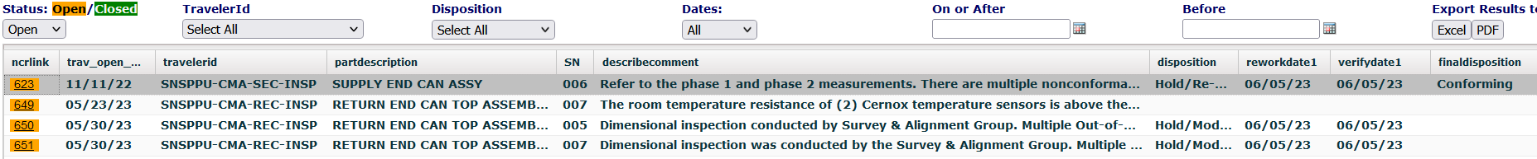

* Open Travelers:

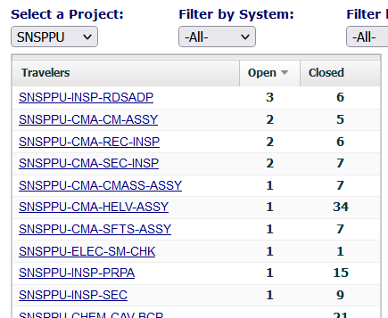

Project Photos: None.