Weekly Reporting SNS PPU
WBS P.02.03 Cryomodule Integration (JLab Scope)
June 16, 2023

Issues: CM-06 cooldown in schedule jeopardy due to safety stand down related to high hazard work. Decision to bypass low power testing at JLab and ship module to ORNL for testing as soon as practically possible.
Accomplishments this week:

Management:
- More new requirements for high risk work activities are emerging at JLab. We are working to ensure that PPU overall is minimally impacted due to this potential change in operation.
- PPU activities are continuing with cryomodule assembly.
- Off-site work efforts continue in the procurement area on end cans.

Engineering & Design:
- Sustaining engineering activities are continuing in order to revise drawing packages based on feedback during the procurement phase with a focus on end can drawing packages.

Procurement:
- End Can vendor visit scheduled for June 21st to witness ASME Pressure testing on SEC08 and inspect REC08.
- Supply End Cans (SECs):
S/N | Status | Estimated Delivery Date
01 | Installed on CM-03
02 | Installed on CM-04
03 | Installed on CM-01
04 | Installed on CM-05
05 | Installed onto CM-06
06 | Delivered to JLab. Uncrated, inspections started. Phase 1 dimensional inspection done. Bridge tube angle is off by ~5 degrees. Welded onto PPU-07. The support block is machined, bridge tube bellows is largely skewed due to dimensional deviations on the SEC 06.
07 | Installed on CM-02
08 | At the vendor. Album 2 cold mass/shield assembly work complete. Currently in prepping for final testing. Vendor will send inspection reports soon. AI witnessed pressure test scheduled for June 21, one from JLAB will witness the test. | Jun 29

- Return End Cans (RECs):
S/N | Status | Estimated Delivery Date
01 | Installed on CM-03
02 | Installed on CM-01
03 | Installed on CM-05
04 | Installed on CM-02
05 | Delivered to JLab on 3/31. Inspection work complete. REC 5 is in position on CM-06. Bridge tube bellows has large deformation. A new support block has been welded onto PPU-06 cryomodule. The residual indium in JT valve is cleared up, a replacement valve seat is installed.
06 | Installed on CM-04
07 | Delivered to JLab on 5/8. Uncrated on 5/10. Receiving inspection work has started and still ongoing. REC 7 is welded to PPU-07 cryomodule after a repair on the bridge tube section.
08 | All interior structure is complete and wrapped in MLI. Album 2 (subassemblies) work completed. Vendor just finished touchup on vacuum vessel welding late yesterday. Will be starting on bridging tube welding. | Jul 13

Production:
- Cryomodule Status:
- CM-06: Ready for cooldown.
- CM-07: REC Process piping complete; SEC close up I.P.
- CM-08: Adding 50k and MLI patch panels; Fit surge tank.
Project Management:
- Sent Cost Package to ORNL
- Provided EV Data to Project Team
- Updated EV Reports
- Updated CAM Notebook

Quality Assurance:
- Continue to monitor quality data for possible trends.
- Continuing to gather/review data deliverables for CM-06.
  - SNSPPU-AFR-002 created for CM-06
    - To Do:
      - Ensure all relevant Work Control Documents related to the product are closed.
      - Confirm data deliverables are complete.
      - Customer confirmation – ready to receive.
      - Property Transfer Form Prepared.
      - SRF Shipping Form prepared.
      - Bill of Lading Form prepared.
      - Traveler ID: SNSPPU-CMA-CM-ASSY for CM-06 is still in progress
- Open NCRs:
  - 1 on REC 005 on CM-06 needs attention
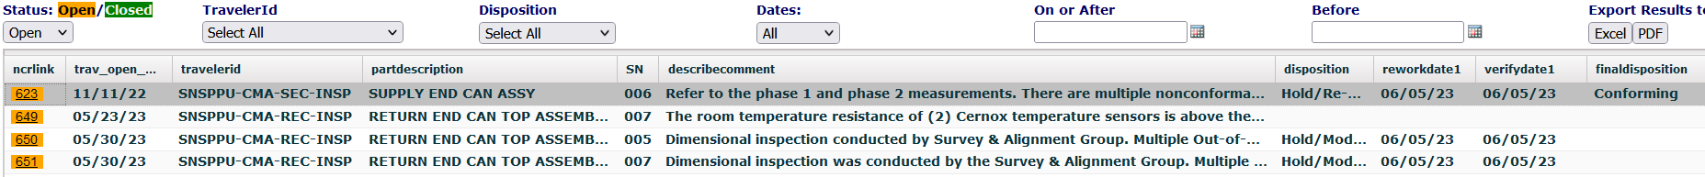

- Open Travelers:
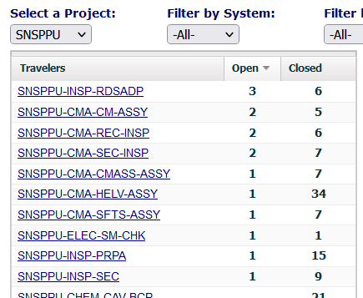

Project Photos:
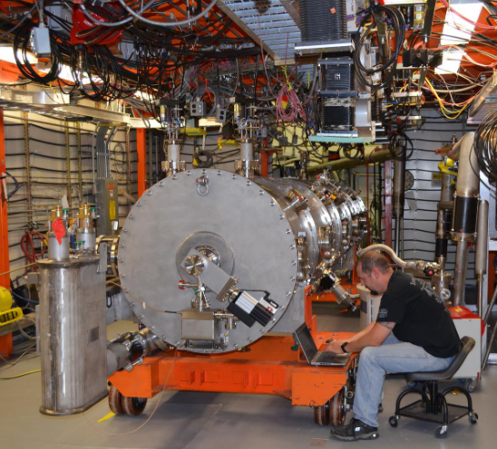
CM06
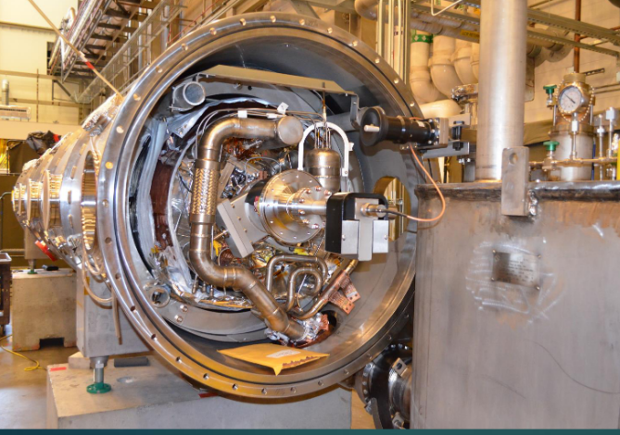
CM07
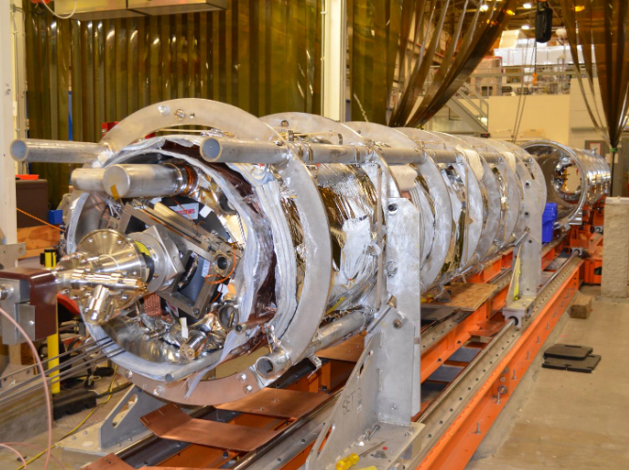
CM08

