Weekly Reporting SNS PPU

WBS P.02.03 Cryomodule Integration (JLab Scope)

July 7, 2023

**Issues:** Safety review of high-risk work is on-going and has delayed work. Current date for shipment of CM-06 is 12-JUL. Pressure testing and welding of CM-07 and CM-08 is on hold pending safety document approvals.

**Accomplishments this week:**

Management:

* Review of high-risk work activities is on-going at JLab.  We are working to ensure that PPU overall is minimally impacted due to this potential change in operation. Currently held up on pressure testing and welding activities
* PPU activities are continuing with cryomodule assembly.
* Off-site work efforts continue in the procurement area on end cans.

Engineering & Design:

* Sustaining engineering activities are continuing in order to revise drawing packages based on feedback during the procurement phase with a focus on end can drawing packages.

Procurement:

* Supply End Cans (SECs):

|  |  |  |
| --- | --- | --- |
| S/N | Status | Estimated Delivery Date |
| 01 | Installed on CM-03 |  |
| 02 | Installed on CM-04 |  |
| 03 | Installed on CM-01 |  |
| 04 | Installed on CM-05 |  |
| 05 | Installed onto CM-06. JLab will ship it to ORNL without cold test at JLab. |  |
| 06 | Delivered to JLab. Uncrated, inspections started. Phase 1 dimensional inspection done. Bridge tube angle is off by ~5 degrees. Welded onto PPU-07. The support block is machined, bridge tube bellows is largely skewed due to dimensional deviations on the SEC 06. |  |
| 07 | Installed on CM-02 |  |
| 08 | Delivered to ORNL on July 6 for investigation on the primary circuit leak. |  |

* Return End Cans (RECs):

|  |  |  |
| --- | --- | --- |
| S/N | Status | Estimated Delivery Date |
| 01 | Installed on CM-03 |  |
| 02 | Installed on CM-01 |  |
| 03 | Installed on CM-05 |  |
| 04 | Installed on CM-02 |  |
| 05 | Delivered to JLab on 3/31. Inspection work complete. REC 5 is in position on CM-06. Bridge tube bellows has large deformation. A new support block has been welded onto PPU-06 cryomodule. The residual indium in JT valve is cleared up, a replacement valve seat is installed.PPU-06 will be shipped to ORNL without cold test at JLab. |  |
| 06 | Installed on CM-04 |  |
| 07 | Delivered to JLab on 5/8. Uncrated on 5/10. Receiving inspection work has started and still ongoing. REC 7 is welded to PPU-07 cryomodule after a repair on the bridge tube section. There is a NCR on two Cernox sensors having abnormal electrical resistances that would need to be evaluated during cryomodule cold test. |  |
| 08 | Main body welding complete, initial prep for bridging tube section is ongoing. Anticipate ~June 30 for HLT on Bridging Tube Elbow section. Possibly scheduling AI visit for REC08 in the week of July 10. | Jul 17 |

Production:

* Cryomodule Status:
* CM-06: Shipping scheduled for July 12.
* CM-07: Completed process piping leak checks. Closing up ends.
* CM-08: Completed adding 50k and MLI patch panels; Fit surge tank.

Project Management:

* Issued Mid-month Manpower charts
* Held Progress Analysis Meeting
* Sent Schedule Package to ORNL
* Updated CAM Notebook

Quality Assurance:

* Continue to monitor quality data for possible trends.
* Continuing to gather/review data deliverables for CM-06.
  + SNSPPU-AFR-002 created for CM-06
    - To Do:
      * Ensure all relevant Work Control Documents related to the product are closed.
      * Confirm data deliverables are complete.
      * Customer confirmation – ready to receive.
      * Property Transfer Form Prepared.
      * SRF Shipping Form prepared.
      * Bill of Lading Form prepared.
      * Traveler ID: SNSPPU-CMA-CM-ASSY for CM-06 is still in progress
* Open NCRs:
  + 1 on REC 005 on CM-06 needs attention

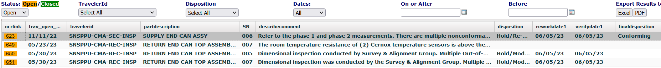

* Open Travelers:

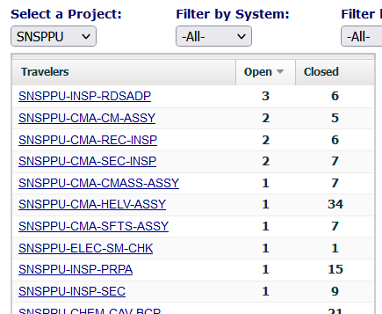

Project Photos:

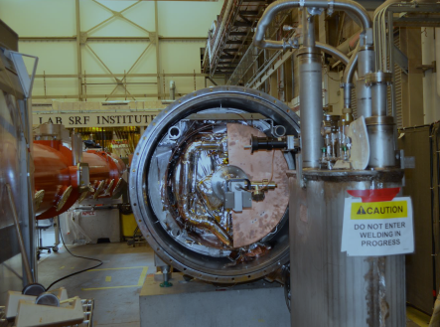

CM07

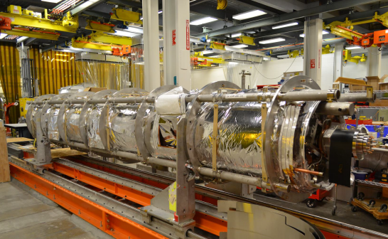

CM08