Weekly Reporting SNS PPU

WBS P.02.03 Cryomodule Integration (JLab Scope)

July 14, 2023

**Issues:** Safety documents have been approved. Full work is authorized for remaining CMs.

**Accomplishments this week:**

Management:

* Review of high-risk work activities is on-going at JLab.  We are working to ensure that PPU overall is minimally impacted due to this potential change in operation. Currently held up on pressure testing and welding activities
* PPU activities are continuing with cryomodule assembly.
* Off-site work efforts continue in the procurement area on end cans.

Engineering & Design:

* Sustaining engineering activities are continuing in order to revise drawing packages based on feedback during the procurement phase with a focus on end can drawing packages.

Procurement:

* JLab will visit the end can vendor's shop on July 18 to witness bridge tube section internal leak check.
* Supply End Cans (SECs):

|  |  |  |
| --- | --- | --- |
| S/N | Status | Estimated Delivery Date |
| 01 | Installed on CM-03 |  |
| 02 | Installed on CM-04 |  |
| 03 | Installed on CM-01 |  |
| 04 | Installed on CM-05 |  |
| 05 | Installed onto CM-06. JLab shipped it to ORNL without cold test at JLab. |  |
| 06 | Delivered to JLab. Welded onto PPU-07. The support block is machined, bridge tube bellows is largely skewed due to dimensional deviations on the SEC 06. |  |
| 07 | Installed on CM-02 |  |
| 08 | Delivered to ORNL on July 6 for investigation on the primary circuit leak. ORNL reported CM leak tight after minor repair. Plan to receive at JLab next week. |  |

* Return End Cans (RECs):

|  |  |  |
| --- | --- | --- |
| S/N | Status | Estimated Delivery Date |
| 01 | Installed on CM-03 |  |
| 02 | Installed on CM-01 |  |
| 03 | Installed on CM-05 |  |
| 04 | Installed on CM-02 |  |
| 05 | Installed onto CM-06. JLab shipped it to ORNL without cold test at JLab. |  |
| 06 | Installed on CM-04 |  |
| 07 | Delivered to JLab on 5/8. Uncrated on 5/10. Receiving inspection work has started and still ongoing. REC 7 is welded to PPU-07 cryomodule after a repair on the bridge tube section. There is a NCR on two Cernox sensors having abnormal electrical resistances that would need to be evaluated during cryomodule cold test. |  |
| 08 | Vendor is working on the welding on the bridging tube area. The last internal weld test in bridging tube area is scheduled to happen early next week. Then it will take about 1-1.5 weeks to finish the exterior jacketing in the bridging area, and about 1.5-2 weeks to complete the final testing. | Aug 7 |

Production:

* Cryomodule Status:
* CM-06: Shipped to ORNL on July 12.
* CM-07: Closing vacuum vessel ends; SEC Beam pipe was assembled.
* CM-08: Welding of coupler exhaust and surge tank lines I.P. SEC failed pressure test and was shipped to ORNL for repair, which pushed out delivery date.

Project Management:

* Sent Cost Package to ORNL
* Updated EV Reports
* Updated CAM Notebook

Quality Assurance:

* Continue to monitor quality data for possible trends.
* Open NCRs
* Open Travelers

Project Photos:

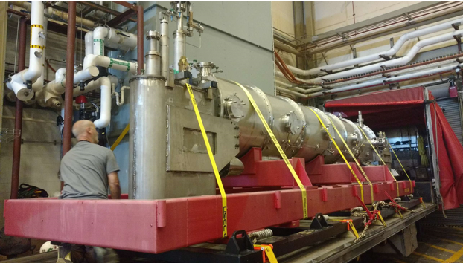

CM-06 shipped to ORNL on July 12.

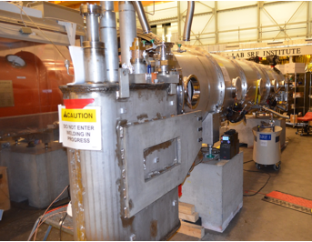

CM-07

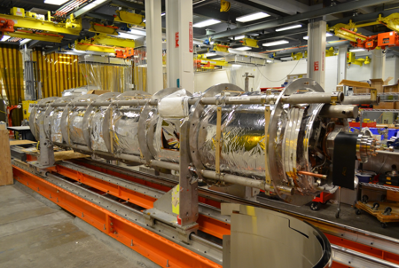

CM-08