Weekly Reporting SNS PPU

WBS P.02.03 Cryomodule Integration (JLab Scope)

July 21, 2023

**Issues:** None.

**Accomplishments this week:**

Management:

* PPU activities are continuing with cryomodule assembly.
* Off-site work efforts continue in the procurement area on end cans.

Engineering & Design:

* Sustaining engineering activities are continuing in order to revise drawing packages based on feedback during the procurement phase with a focus on end can drawing packages.

Procurement:

* JLab will visited the end can vendor on July 18 to witness bridge tube section internal leak check. Next visit will be in approximately two weeks.
* Supply End Cans (SECs):

|  |  |  |
| --- | --- | --- |
| S/N | Status | Estimated Delivery Date |
| 01 | Installed on CM-03 |  |
| 02 | Installed on CM-04 |  |
| 03 | Installed on CM-01 |  |
| 04 | Installed on CM-05 |  |
| 05 | Installed onto CM-06. JLab shipped it to ORNL without cold test at JLab. |  |
| 06 | Delivered to JLab. Welded onto PPU-07. The support block is machined, bridge tube bellows is largely skewed due to dimensional deviations on the SEC 06. |  |
| 07 | Installed on CM-02 |  |
| 08 | Delivered to ORNL on July 6 for investigation on the primary circuit leak. ORNL reported CM leak tight after minor repair. Plan to receive at JLab soon. |  |

* Return End Cans (RECs):

|  |  |  |
| --- | --- | --- |
| S/N | Status | Estimated Delivery Date |
| 01 | Installed on CM-03 |  |
| 02 | Installed on CM-01 |  |
| 03 | Installed on CM-05 |  |
| 04 | Installed on CM-02 |  |
| 05 | Installed onto CM-06. JLab shipped it to ORNL without cold test at JLab. |  |
| 06 | Installed on CM-04 |  |
| 07 | Delivered to JLab on 5/8. Uncrated on 5/10. Receiving inspection work has started and still ongoing. REC 7 is welded to PPU-07 cryomodule after a repair on the bridge tube section. There is a NCR on two Cernox sensors having abnormal electrical resistances that would need to be evaluated during cryomodule cold test. |  |
| 08 | Vendor is working on the welding on the bridging tube area. Fixed a leak in the elbow on the outside of the primary circuit, leak check passed on all circuits. | Aug 7 |

Production:

* Cryomodule Status:
* CM-07: SEC End plate and pump drop installed. REC mli/shielding installed. Final alignment starts 7/24.
* CM-08: Surge tank lines welded. Exhaust line welding I.P. Gathering remainder of parts needed for final assembly.

Project Management:

* Issued Mid-month Manpower charts
* Updated Earned Value Reports
* Provided EV Data to the Project Team
* Updated CAM Notebook

Quality Assurance:

* Continue to monitor quality data for possible trends.
* Open NCRs
* Open Travelers

Project Photos:

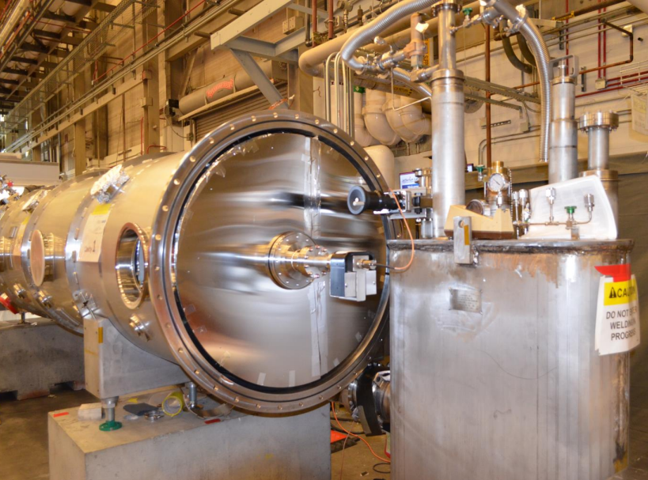

CM-07

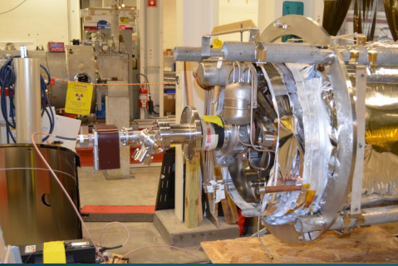

CM-08