Weekly Reporting SNS PPU

WBS P.02.03 Cryomodule Integration (JLab Scope)

August 11, 2023

**Issues:** None.

**Accomplishments this week:**

Management:

* PPU activities are continuing with cryomodule assembly.
* Off-site work efforts continue in the procurement area on end cans.

Engineering & Design:

* Sustaining engineering activities are continuing in order to revise drawing packages based on feedback during the procurement phase with a focus on end can drawing packages.
* Complete set of drawings transmitted on 7/28 to ORNL SNS PPU (S. Stewart) on 7/28.

Procurement:

* JLab visited the end can vendor on August 9 to witness vacuum shell leak check.
* Supply End Cans (SECs):

|  |  |  |
| --- | --- | --- |
| S/N | Status | Estimated Delivery Date |
| 01 | Installed on CM-03 |  |
| 02 | Installed on CM-04 |  |
| 03 | Installed on CM-01 |  |
| 04 | Installed on CM-05 |  |
| 05 | Installed onto CM-06. CM shipped to ORNL without cold test. |  |
| 06 | Delivered to JLab. Welded onto PPU-07. The support block is machined, bridge tube bellows is largely skewed due to dimensional deviations on the SEC 06. |  |
| 07 | Installed on CM-02 |  |
| 08 | SEC 08 was delivered to JLab on July 20 after investigations by ORNL. Visual inspection done. Weld inspection complete. Vacuum shell leak check ongoing, see photo. More inspection steps to follow. |  |

* Return End Cans (RECs):

|  |  |  |
| --- | --- | --- |
| S/N | Status | Estimated Delivery Date |
| 01 | Installed on CM-03 |  |
| 02 | Installed on CM-01 |  |
| 03 | Installed on CM-05 |  |
| 04 | Installed on CM-02 |  |
| 05 | Installed on CM-06 |  |
| 06 | Installed on CM-04 |  |
| 07 | Delivered to JLab on 5/8. There is a NCR on two Cernox sensors having abnormal electrical resistances that would need to be evaluated during cryomodule cold test. |  |
| 08 | AI witnessed ASME pressure test is scheduled to happen on 8/11. JLAB witnessed vacuum shell leak check on 8/9. Multiple issues are encountered so that the leak check is postponed to 8/10. AI visit still scheduled to be on 8/11. A couple of REC 8 photos are attached to show its current state. Estimated to ship in the week of 8/21. | Aug 21 |

Production:

* Cryomodule Status:
* CM-07: Final assembly I.P. Going into CMTF; cooldown next week.
* CM-08: In vacuum vessel and aligned; lockdown welding I.P.; coupler exhaust manifold added; SEC LC/PT in progress.

Project Management:

* Updated EV Reports
* Sent Cost Package to ORNL
* Updated CAM Notebook

Quality Assurance:

* Continue to monitor quality data for possible trends
* Reported on Open NCRs, Travelers and CAPAs

Project Photos:

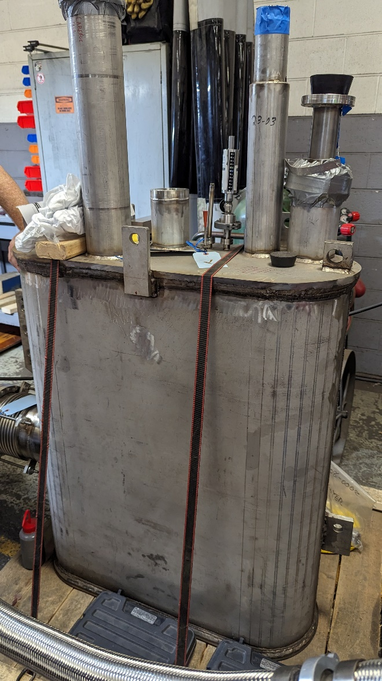

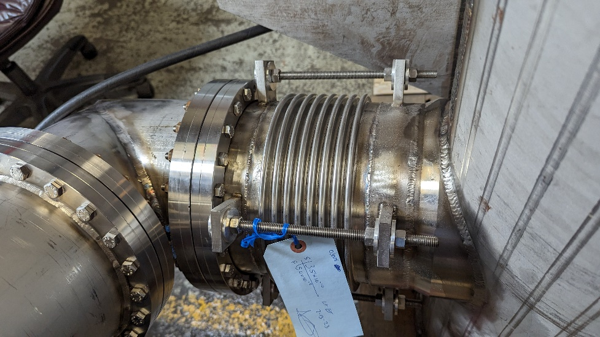

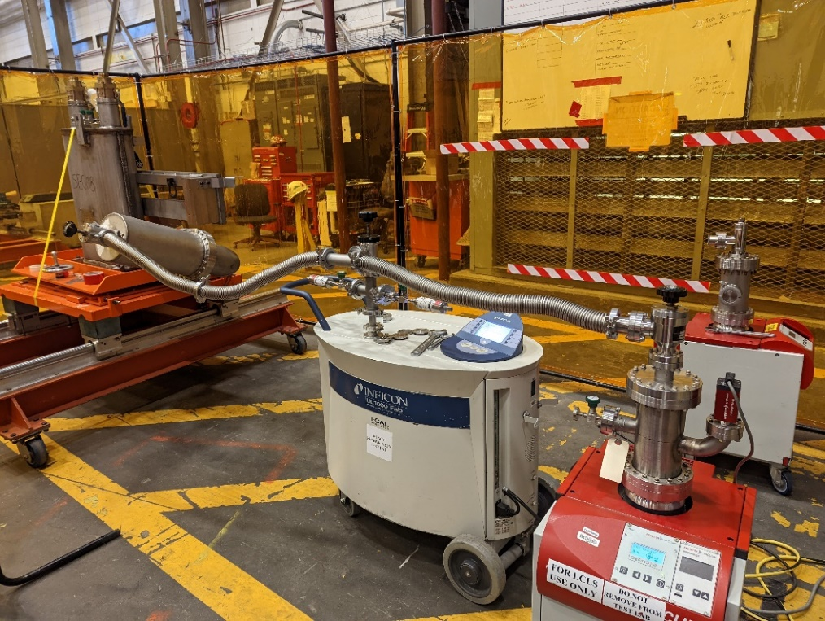

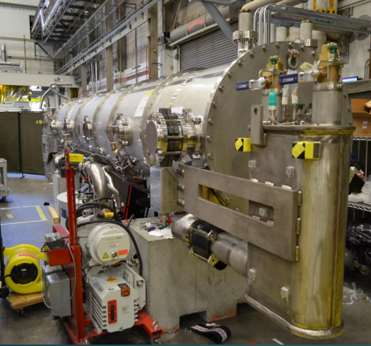

CM-07

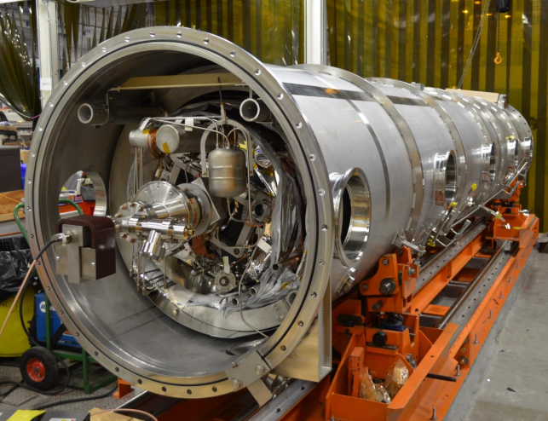

CM-08