Weekly Reporting SNS PPU

WBS P.02.03 Cryomodule Integration (JLab Scope)

August 18, 2023

**Issues:** None.

**Accomplishments this week:**

Management:

* PPU activities are continuing with cryomodule assembly.
* Off-site work efforts continue in the procurement area on end cans.
* Prepared BCR for extending period of performance to 31-March-2024.
* Presented project status at JLab Planning and Coordination meeting (8/18).

Engineering & Design:

* Sustaining engineering activities are continuing in order to revise drawing packages based on feedback during the procurement phase with a focus on end can drawing packages.

Procurement:

* Supply End Cans (SECs):

|  |  |  |
| --- | --- | --- |
| S/N | Status | Estimated Delivery Date |
| 01 | Installed on CM-03 |  |
| 02 | Installed on CM-04 |  |
| 03 | Installed on CM-01 |  |
| 04 | Installed on CM-05 |  |
| 05 | Installed onto CM-06. CM shipped to ORNL without cold test. |  |
| 06 | Delivered to JLab. Welded onto PPU-07. The support block is machined, bridge tube bellows is largely skewed due to dimensional deviations on the SEC 06. |  |
| 07 | Installed on CM-02 |  |
| 08 | SEC 08 was delivered to JLab on July 20 after investigations by ORNL. Receiving inspection work is complete. |  |

* Return End Cans (RECs):

|  |  |  |
| --- | --- | --- |
| S/N | Status | Estimated Delivery Date |
| 01 | Installed on CM-03 |  |
| 02 | Installed on CM-01 |  |
| 03 | Installed on CM-05 |  |
| 04 | Installed on CM-02 |  |
| 05 | Installed on CM-06 |  |
| 06 | Installed on CM-04 |  |
| 07 | Delivered to JLab on 5/8. There is a NCR on two Cernox sensors having abnormal electrical resistances that would need to be evaluated during cryomodule cold test. Discovered remnants in the JT valve after removing of the stem. Decide to proceed with testing to see if the JT would seal. |  |
| 08 | Vendor is working on final testing and should be wrapping up end of next week or start of the following week. | Sep 5 |

Production:

* Cryomodule Status:
* CM-07: In CMTF; u-tubes/cooldown I.P.
* CM-08: Lockdowns/coupler exhaust welding complete; cold mass alignment in VV done; final alignment scheduled for August 18; SEC-08 R.I. done and ready for use.

Project Management:

* Completed VARs
* Updated EV Reports
* Updated CAM Notebook

Quality Assurance:

* Continue to monitor quality data for possible trends
* Reported on Open NCRs, Travelers and CAPAs

Project Photos:

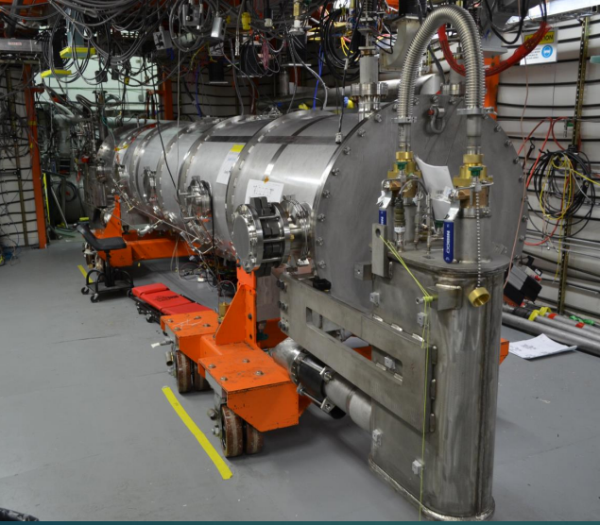

CM-07

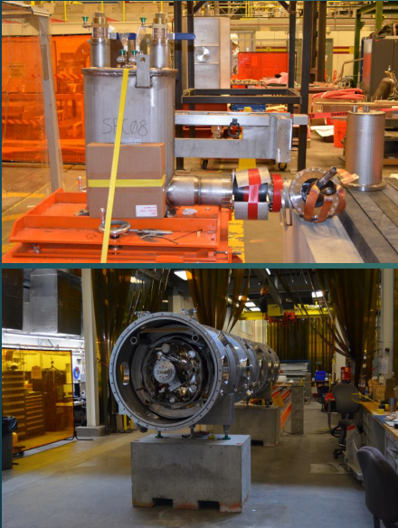

CM-08