Weekly Reporting SNS PPU

WBS P.02.03 Cryomodule Integration (JLab Scope)

August 25, 2023

**Issues:** None.

**Accomplishments this week:**

Management:

* PPU activities are continuing with cryomodule assembly.
* Off-site work efforts continue in the procurement area on end cans.
* Presented project status at monthly JLab Director’s Review (8/22).
* Maintaining a long-standing tradition, the team at JLab is signing the 7th CM.

Engineering & Design:

* Sustaining engineering activities are continuing in order to revise drawing packages based on feedback during the procurement phase with a focus on end can drawing packages.

Procurement:

* One visitor from JLab will witness final pressure/leak tests of REC 8 on August 29.
* Supply End Cans (SECs):

|  |  |  |
| --- | --- | --- |
| S/N | Status | Estimated Delivery Date |
| 01 | Installed on CM-03 |  |
| 02 | Installed on CM-04 |  |
| 03 | Installed on CM-01 |  |
| 04 | Installed on CM-05 |  |
| 05 | Installed onto CM-06. CM shipped to ORNL without cold test. |  |
| 06 | Delivered to JLab. Welded onto PPU-07. The support block is machined, bridge tube bellows is largely skewed due to dimensional deviations on the SEC 06. |  |
| 07 | Installed on CM-02 |  |
| 08 | SEC 08 was delivered to JLab on July 20 after investigations by ORNL. Receiving inspection work is complete. SEC 08 is planned to be installed onto PPU-08. |  |

* Return End Cans (RECs):

|  |  |  |
| --- | --- | --- |
| S/N | Status | Estimated Delivery Date |
| 01 | Installed on CM-03 |  |
| 02 | Installed on CM-01 |  |
| 03 | Installed on CM-05 |  |
| 04 | Installed on CM-02 |  |
| 05 | Installed on CM-06 |  |
| 06 | Installed on CM-04 |  |
| 07 | Delivered to JLab on 5/8. There is a NCR on two Cernox sensors having abnormal electrical resistances that would need to be evaluated during cryomodule cold test. Discovered remnants in the JT valve after removing of the stem. Decide to proceed with testing to see if the JT would seal. |  |
| 08 | Preliminary helium leak test and then preliminary (without AI) pressure test are complete. Working on setting up for cold shock test. Hope to be into internal line testing. AI witnessed test scheduled for Tuesday 8/29 afternoon. | Aug 31 |

Production:

* Cryomodule Status:
* CM-07: In CMTF; shipping scheduled for August 30.
* CM-08: Final alignment complete; SEC08 in position; alignment August 29.

Project Management:

* Sent Progress Sheets out to CAMs
* Completed VARs
* Completed BCR 23-004

Quality Assurance:

* Continue to monitor quality data for possible trends
* Reported on Open NCRs, Travelers and CAPAs

Project Photos:

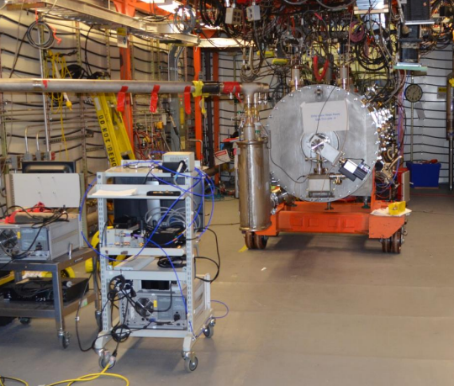

CM-07

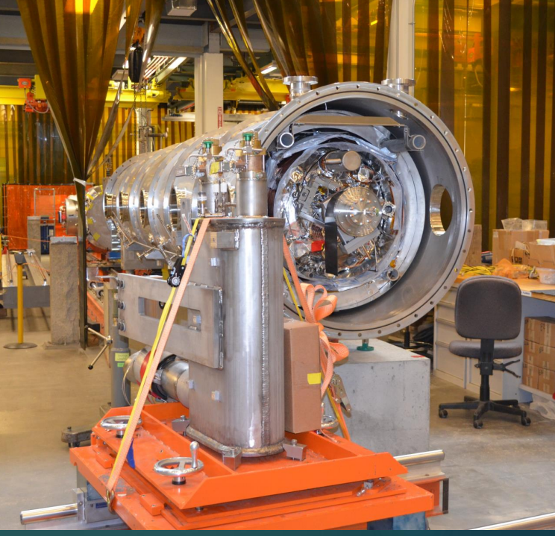

CM-08