Weekly Reporting SNS PPU

WBS P.02.03 Cryomodule Integration (JLab Scope)

September 8, 2023

**Issues:** None.

**Accomplishments this week:**

Management:

* PPU activities are continuing with cryomodule assembly.
* Off-site work efforts continue in the procurement area on end cans.
* Provided update on PEMP goals to AccDiv leadership for S&T review last week

Engineering & Design:

* Sustaining engineering activities are continuing in order to revise drawing packages based on feedback during the procurement phase with a focus on end can drawing packages.

Procurement:

* Supply End Cans (SECs):

|  |  |  |
| --- | --- | --- |
| S/N | Status | Estimated Delivery Date |
| 01 | Installed on CM-03 |  |
| 02 | Installed on CM-04 |  |
| 03 | Installed on CM-01 |  |
| 04 | Installed on CM-05 |  |
| 05 | Installed on CM-06 |  |
| 06 | Delivered to JLab. Welded onto PPU-07. The support block is machined, bridge tube bellows is largely skewed due to dimensional deviations on the SEC 06. |  |
| 07 | Installed on CM-02 |  |
| 08 | SEC 08 was delivered to JLab on July 20 after investigations by ORNL. Receiving inspection work is complete. Support block is machined and installed (see photo). |  |

* Return End Cans (RECs):

|  |  |  |
| --- | --- | --- |
| S/N | Status | Estimated Delivery Date |
| 01 | Installed on CM-03 |  |
| 02 | Installed on CM-01 |  |
| 03 | Installed on CM-05 |  |
| 04 | Installed on CM-02 |  |
| 05 | Installed on CM-06 |  |
| 06 | Installed on CM-04 |  |
| 07 | Delivered to JLab on 5/8. There is a NCR on two Cernox sensors having abnormal electrical resistances that would need to be evaluated during cryomodule cold test. Discovered remnants in the JT valve after removing of the stem. Decide to proceed with testing to see if the JT would seal. |  |
| 08 | AI Inspection of REC08 is complete, REC08 passed its pressure check and received its signature from the AI. Primary Return, Primary Supply and Coupler circuits passed pressure leak check. Shield Circuit pressure sensitive leak is found to be on a weld, which is repaired. Preliminary leak check is ok, vendor is establishing better background vacuum and repeat the pressure leak check on the shield circuit. | Sep 14  (ship from vendor) |

Production:

* Cryomodule Status:
* CM-08: SEC08 in position and aligned. Welding to start next week after locating some valve parts.

Project Management:

* Held Progress Analysis Meeting
* Sent Schedule Package to ORNL
* Updated CAM Notebook

Quality Assurance:

* Continue to monitor quality data for possible trends
* Reported on Open NCRs, Travelers and CAPAs at bi-weekly meeting

Project Photos:

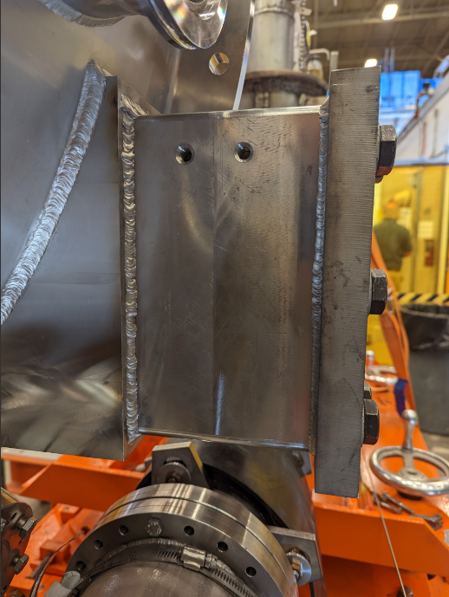

SEC-08