Weekly Reporting SNS PPU

WBS P.02.03 Cryomodule Integration (JLab Scope)

September 22, 2023

**Issues:** None.

**Accomplishments this week:**

Management:

* PPU activities are continuing with cryomodule assembly.
* No further off-site work for procurements as last end can was received.
* Prepare slides for monthly Director’s Review planned for 9/26.

Engineering & Design:

* Sustaining engineering activities are continuing in order to revise drawing packages based on feedback during the procurement phase with a focus on end can drawing packages.

Procurement:

* Return End Cans (RECs):

|  |  |  |
| --- | --- | --- |
| S/N | Status | Estimated Delivery Date |
| 01 | Installed on CM-03 |  |
| 02 | Installed on CM-01 |  |
| 03 | Installed on CM-05 |  |
| 04 | Installed on CM-02 |  |
| 05 | Installed on CM-06 |  |
| 06 | Installed on CM-04 |  |
| 07 | Installed on CM-07 |  |
| 08 | JLab instructed the vendor to ship REC 08 on 9/20. | 9/22 |

Production:

* CM-08 Status:
* SEC08 in position and aligned. Welding on hold awaiting some valve parts.
* REC08 was received on 9/21 and unboxed. Inspection and leak check will begin next week.
* Shipping date TBD based on upcoming inspection and leak test results.

Project Management:

* Provided EV Data to Project Team
* Updated EV Reports
* Updated CAM Notebook

Quality Assurance:

* Continue to monitor quality data for possible trends
* Reported on Open NCRs, Travelers and CAPAs at bi-weekly meeting

Project Photos:

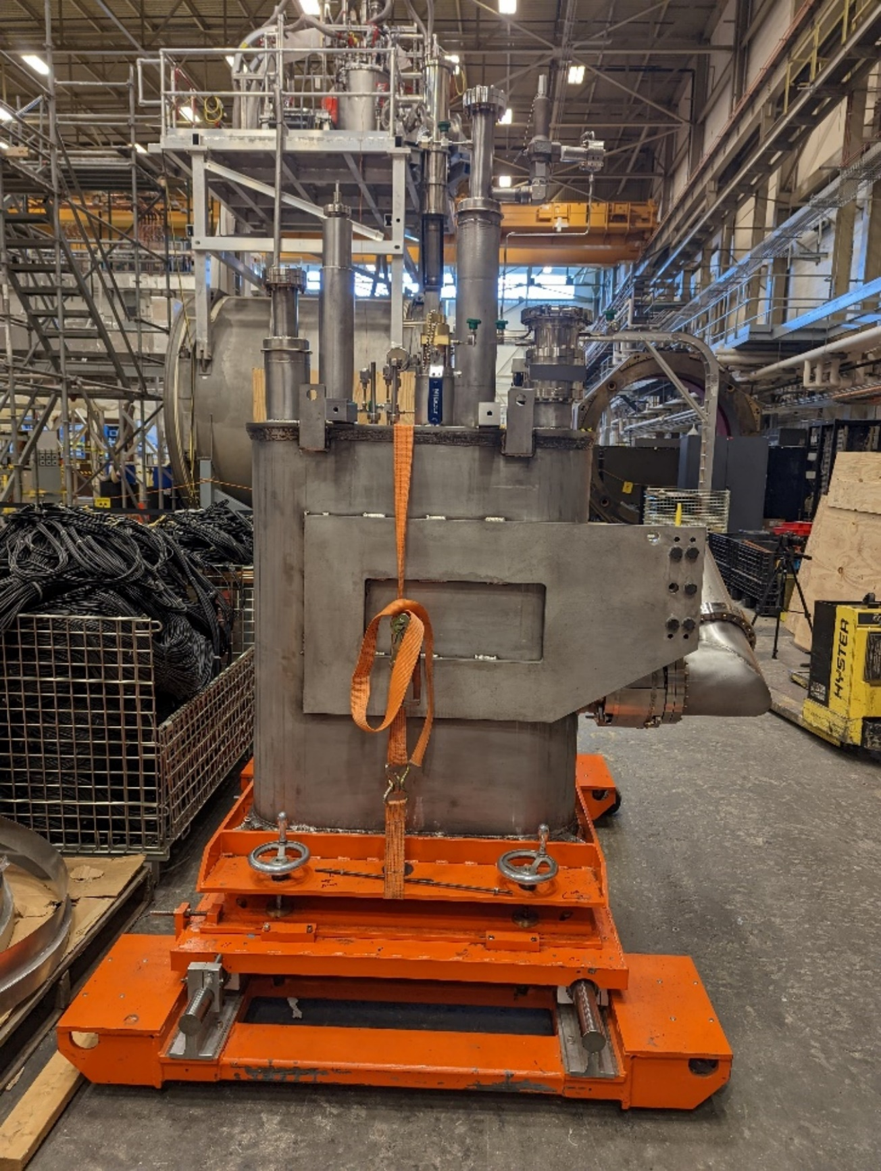

Return End Can received in Test Lab on 9/22.