# Applicant: Narbe Kalantarians, Ph.D.

# Host: Shunzo Kumano, Ph. D.

# Research Summary and Plan

The applicant and collaborators have examined the Iron-56 structure function *F2Fe* for differences in *F2Fe* between the charged lepton and neutrino scattering data. Most of the published data analyses for these were in EMC ratio form of Iron/Deuteron (i.e. *F2Fe/ F2D*). Therefore, a reliable parameterization of the deuteron was used to determine *F2Fe.* The main result is illustrated in Figure 1, where *F2Fe* is plotted versus momentum scaling variable *x*, showing neutrino data (top 3 data sets in the key) rising at lowest *x* while charged lepton data seems to flatten. This work has been published as a Rapid Communication [1], and is considered very interesting by both the charged lepton and neutrino scattering communities because the observations seem to suggest that there is shadowing - indicative of the flattening - in charged lepton scattering, but not in neutrino scattering, and also showing the dependence on *F2D*. A definition of *F2* is given in the following research summary section.

The latest study in involved obtaining the *F2p,n* ratios of nuclei to proton and neutron. The applicant and a student participant obtained published EMC ratio data. With the application of reliable parameterizations for deuteron and proton [2], the applicant and student obtained information on *F2A/F2p*. A collaborator obtained information on *F2A/F2n* by incorporating a model for nucleons [3]. Here, the *A* superscriptrepresents nuclei heavier than deuteron. A theory collaborator has provided a calculation to compare these ratios to. It should be mentioned that the neutron model is heavily driven by deuteron data, with BONuS [4] being the sole source of neutron target data. As shown in Figure 2, this study looked at a broad range of nuclei. With the interest of the nuclear physics community, the paper is currently in the final stage of review for publication [5].

The applicant’s plan for this proposal is to explore how these can be further studied (as well as what possible branch-offs from this) at the future planned electron-ion collider. Topics to explore are kinematic regions of interest, impact on EMC studies. The applicant would stay at KEK for this visit and requests 3 weeks for this stay. These findings would be summarized in a write-up that would be submitted for publication.

**Collaboration**

The applicant would be working with Dr. Kumano at KEK. Dr. Kumano is a theorist and well-known authority on the applicant’s subjects of interest. The applicant has corresponded and worked with Dr. Kumano since 2013 on these mentioned topics as well as on nucleon/nuclear tensor spin structure, including development of a proposal for the PAC. With the applicant being an experimentalist, this would indeed be a complementary effort.

**Itinerary**

The applicant and Dr. Kumano would schedule 2-3 meetings each week, during the applicant’s stay at KEK. The first week would be focused on brain-storming, to decide which topics would require more focus/priority. The second week would be dedicated towards working on fleshing out the relevant details. The third week would entail recapping and planning the intended write-up. During the second or third week, the applicant would be willing to present the effort for a seminar.

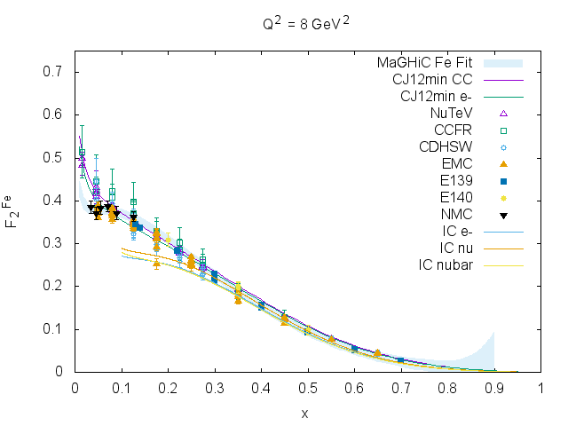

Figure 1: Iron-56 structure function F256 plotted versus momentum transfer ratio x. Curves are from calculations and parameterizations detailed in Ref[1].

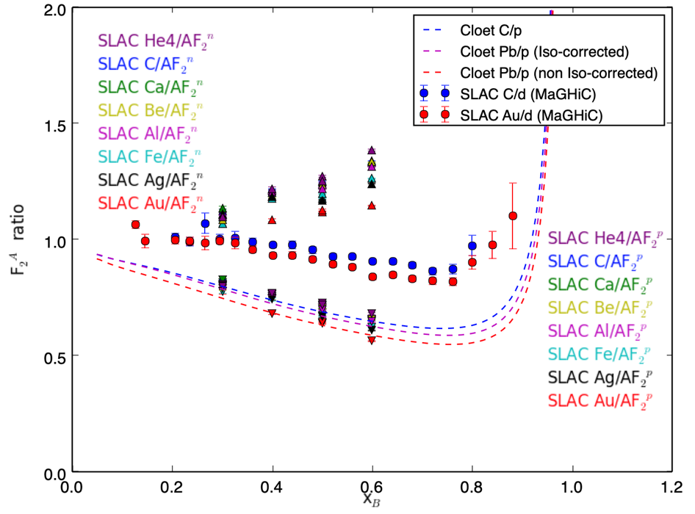

Figure 2: Structure Function F2 ratios of nuclei to neutron and proton vs. momentum fraction x. From Ref[5].

**References**

1) N. Kalantarians, C. Keppel, M.E. Christy, Phys. Rev. C **96** 032201(R) (2017).

2) P. Amaudruz et al, Physics Letters B, **295**, 159 (1992).

3) J. F. Owens, A. Accardi, and W. Melnitchouk, Phys. Rev. D **87**, 094012 (2013).

4) S. Tkachenko et al, Phys. Rev. C, **89,** 045206 (2014).

5) H. Szumila-Vance, I. Cloet, C. Keppel, S. Esclante, N. Kalantarians, Manuscript in progress, intended for Phys. Rev. C.